PRINCE2 Agile®
Practitioner

Delegate
Workbook

PRINCE2 Agile® is a registered trade mark of AXELOS Limited, used under permission of AXELOS Limited. All rights reserved.

Geoff Rankins asserts his moral right to be acknowledged as author of this work.

Copyright © 2015-2017 Aspire Australasia Pty Ltd unless otherwise stated. All rights reserved.

This publication is sold subject to the condition that it, or any part of it, shall not by way of trade or otherwise, be sold, lent, re-sold, displayed, advertised or otherwise circulated, without the publisher’s prior written consent, in any form of binding, cover or title other than that in which it is published and without a similar condition including this condition being imposed on the subsequent purchaser(s).
This publication is sold subject to the condition that it, or any part of it, shall not be reproduced, stored or transmitted, without the publisher’s prior written consent, and without a similar condition including this condition being imposed on the subsequent purchaser(s).

Published under license by:

Inspiring Projects
www.InspiringProjects.com.au
training@InspiringProjects.com.au

Based on AXELOS PRINCE2 Agile material. Material reproduced under licence from AXELOS Limited. All rights reserved.
Direct quotes from the PRINCE2 Agile 2015 Manual are marked as: … PRINCE2 Agile text

Welcome

Welcome to our PRINCE2 Agile Practitioner Course. This is one element of our suite of project management training courses, designed to assist both individuals and organisations.

The strength of PRINCE2 lies in the areas of project direction and project management whereas agile has a very strong focus on product delivery. When PRINCE2 and agile are combined, project direction, project management and project delivery are all optimized to create the world's most complete project management solution. PRINCE2 Agile is the most up-to-date and relevant view of agile project management methods, and the only framework covering a wide range of agile concepts, including SCRUM, Kanban and Lean Startup.

This course is designed to introduce you to the PRINCE2 Agile approach to project management, and lead you through a series of practical activities so that by the end of the course you will have a competent understanding of PRINCE2 Agile.

Inspiring Projects is a privately owned provider of project management and project related services and training. The company provides consultancy services to clients including consulting firms, large corporates, SMEs, Universities, multinationals, and State and Federal Government Departments and agencies. We have provided our services across Australasia and Africa. For the past ten years, our instructors have been successfully training participants to understand and use the PRINCE2 method as well as pass the related examinations. The mission of the company is to support organisations undertaking projects, changing their environment or introducing standard project and programme management methods, through the provision of high quality consultancy and management support. This support includes professional programme and project management services, training, certification, consultancy and associated services to assist clients to develop their expertise in the efficient organisation and profitable delivery of programmes and projects. Our consultants have developed project management systems built around PRINCE2, and we have provided Executive Briefings, coaching, mentoring and interim staffing support to ensure our clients maximise the benefits from their investment in PRINCE2.

We are pleased to be able to assist in your training and trust that you will find the course beneficial and interesting.

Geoff Rankins
Lead Trainer
Inspiring Projects

This page intentionally left blank

Table of Contents
1. Course Schedule 7
2. Introducing Agile 8
3. Introducing PRINCE2 Agile 16
4. Focus Areas 25
5. Tailoring PRINCE2 Principles and Management Products 32
6. Tailoring PRINCE2 Themes 36
7. Tailoring PRINCE2 Processes 48
8. PRINCE2 Agile Summary 61
9. Course Closure 64
10. The PRINCE2 Agile Practitioner Exam 66
11. Case Study and Activities 69
12. Answers to Review Questions 81
13. Answers to Activities 82

This page intentionally left blank

Course Schedule
Day 1 | Session
08:45 | 1  2 | Introductions  Introducing Agile  Morning break
12:30 |  | Lunch (45 mins)
13:15 | 3  4 | Introducing PRINCE2 Agile  Afternoon break  Focus Areas
16:30 |  | CLOSE
Homework |  | Read Appendix B – Roles and Responsibilities
Day 2 | Session
08:45 | 5  6 | Review of yesterday & homework  Tailoring Principles and Management Products  Morning break  Tailoring Themes
12:30 |  | Lunch (45 mins)
13:15 | 7 | Tailoring Themes (continued)  Afternoon break  Tailoring processes
16:30 |  | CLOSE
Homework |  | Read Appendix G – Advice for a Project Manager using agile
Day 3 | Session
08:45 | 8  9 | Review of yesterday & homework  Tailoring processes (continued)  PRINCE2 Agile Summary  Morning break  Sample PRINCE2 Agile Practitioner paper
12:30 |  | Lunch (45 mins)
13:15 | 10 | PRINCE2 Agile Practitioner Examination
16:30 |  | CLOSE

Introducing Agile

Slides
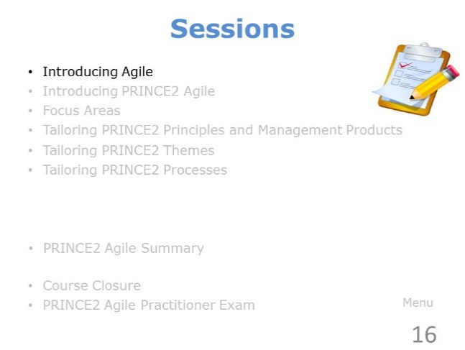 | ………………….………………………….……………………………..  ……………………….……………….…………………………………..  ………………………….……….………………………………………..  ………………….………….……………………………………………..  …………………………………..………………………………………..
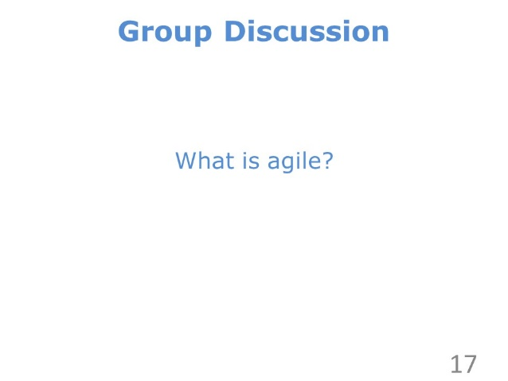 | ………………….………………………….……………………………..  ……………………….……………….…………………………………..  ………………………….……….………………………………………..  ………………….………….……………………………………………..  …………………………………..………………………………………..
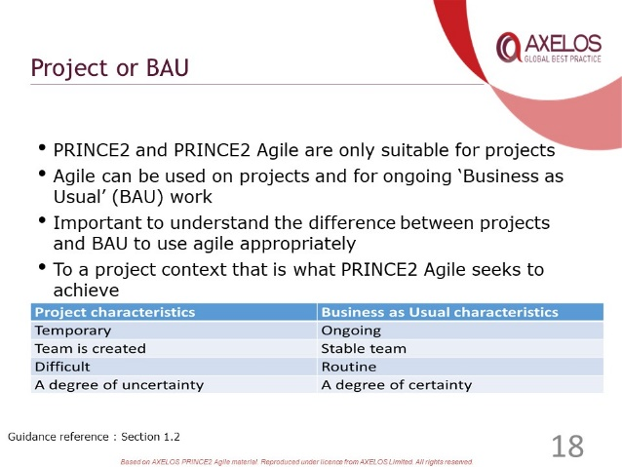 | ………………….………………………….……………………………..  ……………………….……………….…………………………………..  ………………………….……….………………………………………..  ………………….………….……………………………………………..  …………………………………..………………………………………..
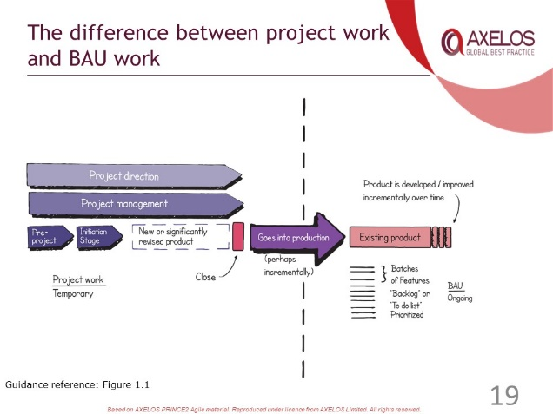 | ………………….………………………….……………………………..  ……………………….……………….…………………………………..  ………………………….……….………………………………………..  ………………….………….……………………………………………..  …………………………………..………………………………………..
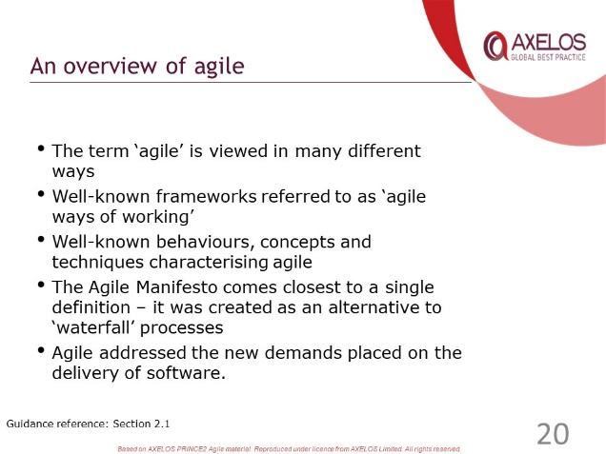 | ………………….………………………….……………………………..  ……………………….……………….…………………………………..  ………………………….……….………………………………………..  ………………….………….……………………………………………..  …………………………………..………………………………………..
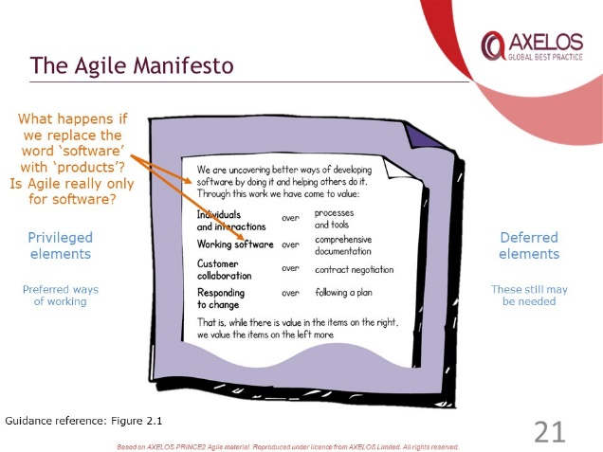 | ………………….………………………….……………………………..  ……………………….……………….…………………………………..  ………………………….……….………………………………………..  ………………….………….……………………………………………..  …………………………………..………………………………………..
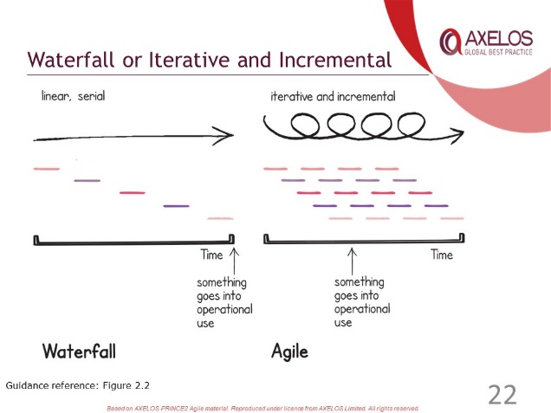 | ………………….………………………….……………………………..  ……………………….……………….…………………………………..  ………………………….……….………………………………………..  ………………….………….……………………………………………..  …………………………………..………………………………………..
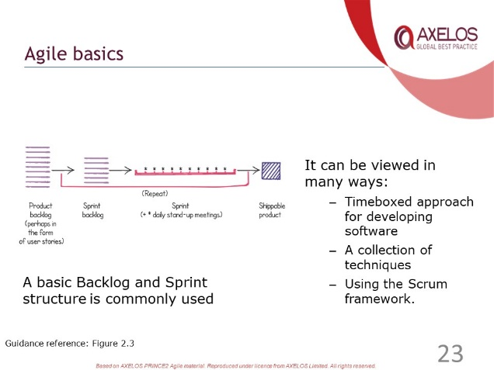 | ………………….………………………….……………………………..  ……………………….……………….…………………………………..  ………………………….……….………………………………………..  ………………….………….……………………………………………..  …………………………………..………………………………………..
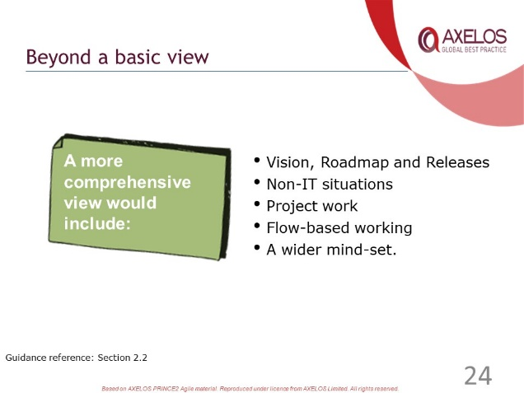 | ………………….………………………….……………………………..  ……………………….……………….…………………………………..  ………………………….……….………………………………………..  ………………….………….……………………………………………..  …………………………………..………………………………………..
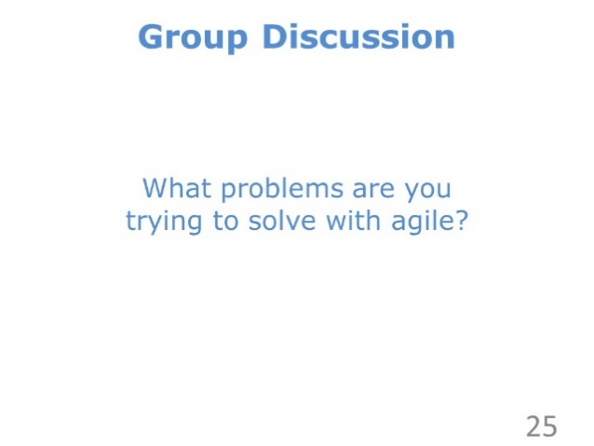 | ………………….………………………….……………………………..  ……………………….……………….…………………………………..  ………………………….……….………………………………………..  ………………….………….……………………………………………..  …………………………………..………………………………………..
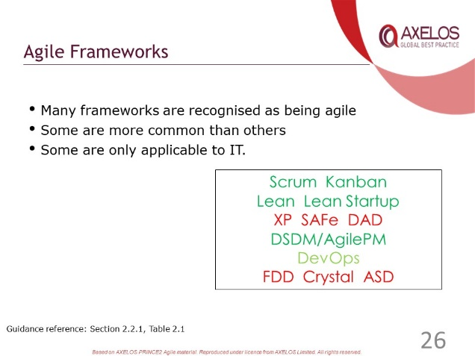 | ………………….………………………….……………………………..  ……………………….……………….…………………………………..  ………………………….……….………………………………………..  ………………….………….……………………………………………..  …………………………………..………………………………………..
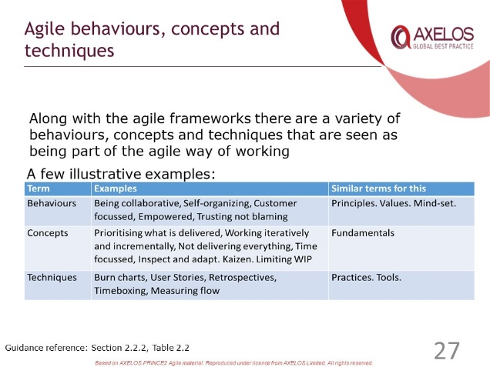 | ………………….………………………….……………………………..  ……………………….……………….…………………………………..  ………………………….……….………………………………………..  ………………….………….……………………………………………..  …………………………………..………………………………………..
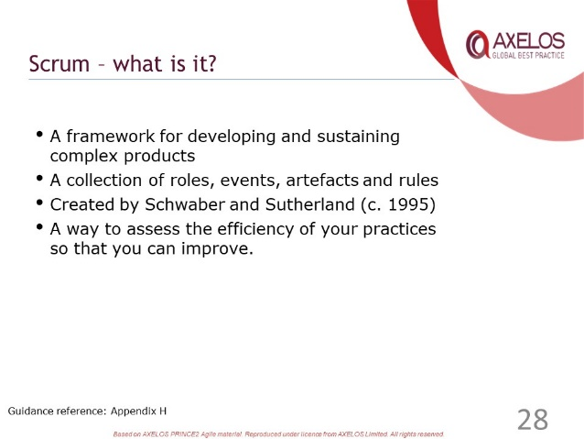 | ………………….………………………….……………………………..  ……………………….……………….…………………………………..  ………………………….……….………………………………………..  ………………….………….……………………………………………..  …………………………………..………………………………………..
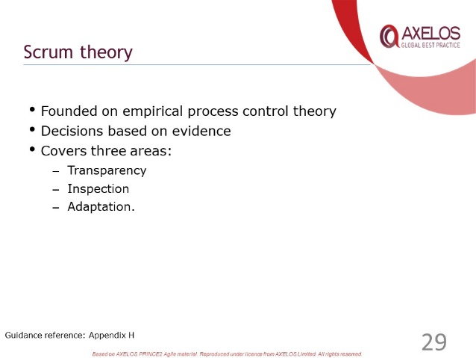 | ………………….………………………….……………………………..  ……………………….……………….…………………………………..  ………………………….……….………………………………………..  ………………….………….……………………………………………..  …………………………………..………………………………………..
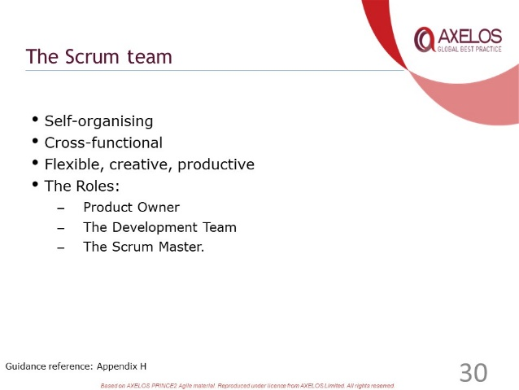 | ………………….………………………….……………………………..  ……………………….……………….…………………………………..  ………………………….……….………………………………………..  ………………….………….……………………………………………..  …………………………………..………………………………………..
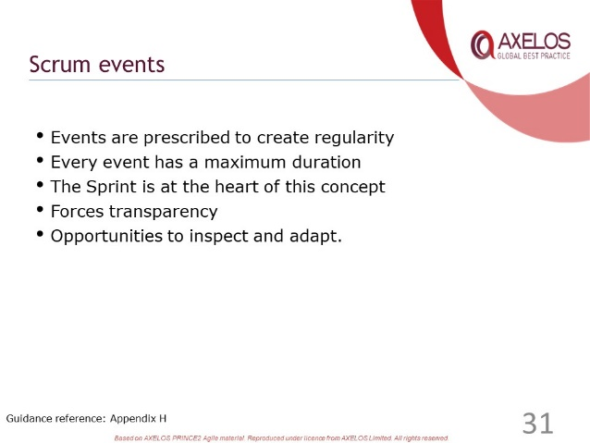 | ………………….………………………….……………………………..  ……………………….……………….…………………………………..  ………………………….……….………………………………………..  ………………….………….……………………………………………..  …………………………………..………………………………………..
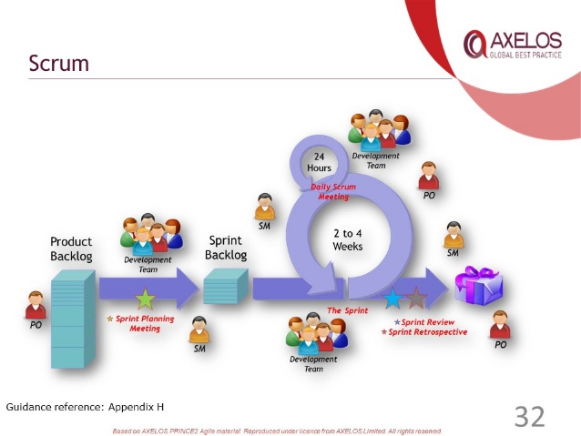 | ………………….………………………….……………………………..  ……………………….……………….…………………………………..  ………………………….……….………………………………………..  ………………….………….……………………………………………..  …………………………………..………………………………………..
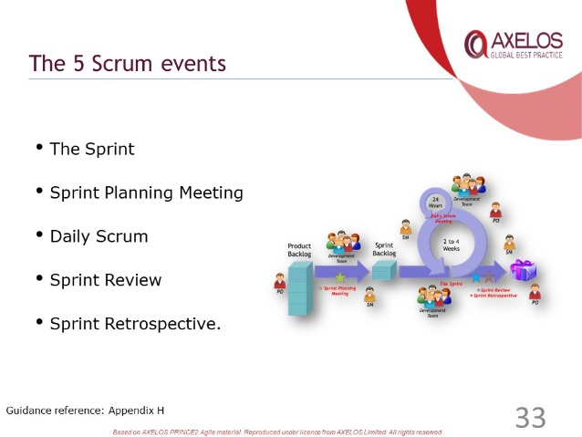 | ………………….………………………….……………………………..  ……………………….……………….…………………………………..  ………………………….……….………………………………………..  ………………….………….……………………………………………..  …………………………………..………………………………………..
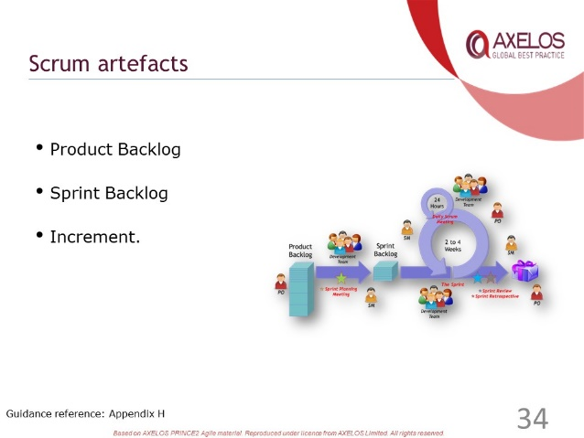 | ………………….………………………….……………………………..  ……………………….……………….…………………………………..  ………………………….……….………………………………………..  ………………….………….……………………………………………..  …………………………………..………………………………………..
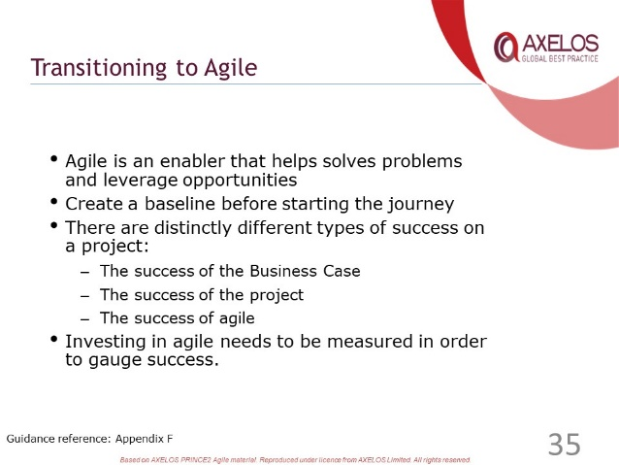 | ………………….………………………….……………………………..  ……………………….……………….…………………………………..  ………………………….……….………………………………………..  ………………….………….……………………………………………..  …………………………………..………………………………………..
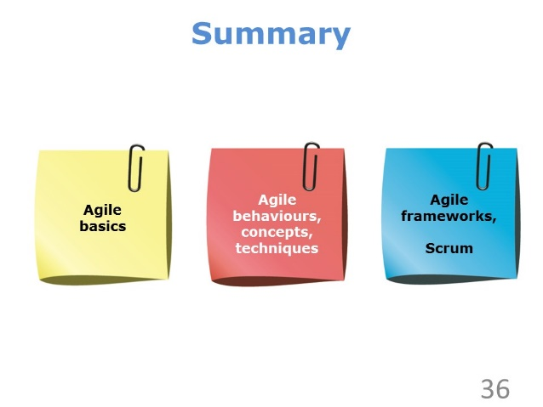 | ………………….………………………….……………………………..  ……………………….……………….…………………………………..  ………………………….……….………………………………………..  ………………….………….……………………………………………..  …………………………………..………………………………………..
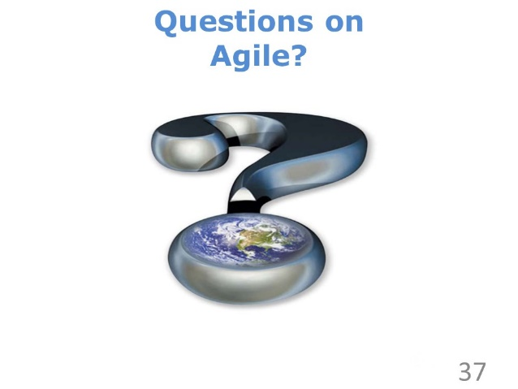 | ………………….………………………….……………………………..  ……………………….……………….…………………………………..  ………………………….……….………………………………………..  ………………….………….……………………………………………..  …………………………………..………………………………………..

Review Questions – Agile

1 | Which of the following is not an agile framework?  a) Prioritising what is delivered  b) Scrum  c) Kanban  d) Lean Startup
2 | Which of the following best describes an agile approach that can be integrated with PRINCE2 Agile?  a) Valuing customer collaboration over contract negotiation  b) A way to provoke system improvement through controlling work in progress  c) Providing guidance to tailor process and themes  d) Trading off scope, cost, time, risk, benefits and quality
3 | Which of the following is not associated with Scrum?  a) Sprint  b) Retrospective  c) Daily standup  d) Pivot
4 | Complete the following sentence: “PRINCE2 Agile regards agile as a family of behaviours, concepts, frameworks and …”  a) Attitudes  b) Assumptions  c) Techniques  d) Procedures
5 | Which of the following is a characteristic of business-as-usual work?  a) A new product or service is being created  b) The work may be part of a wider programme of work  c) Repeatable routine tasks  d) PRINCE2 is not useful in engineering projects

Check your answers with those on page 81.

Introducing PRINCE2 Agile

Slides
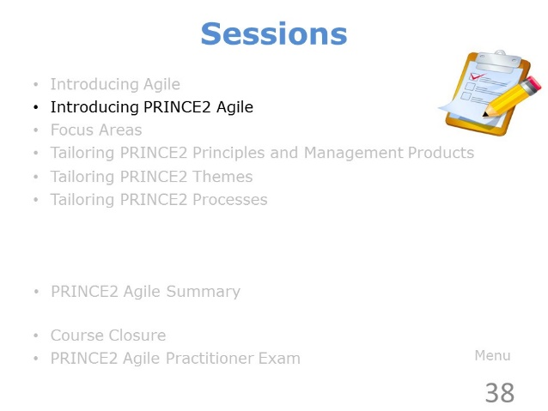 | ………………….………………………….……………………………..  ……………………….……………….…………………………………..  ………………………….……….………………………………………..  ………………….………….……………………………………………..  …………………………………..………………………………………..
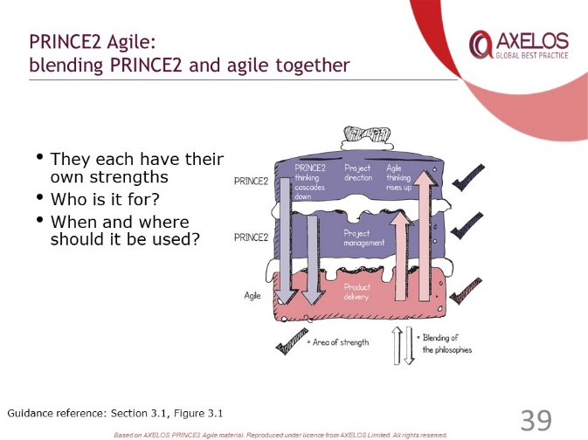 | ………………….………………………….……………………………..  ……………………….……………….…………………………………..  ………………………….……….………………………………………..  ………………….………….……………………………………………..  …………………………………..………………………………………..
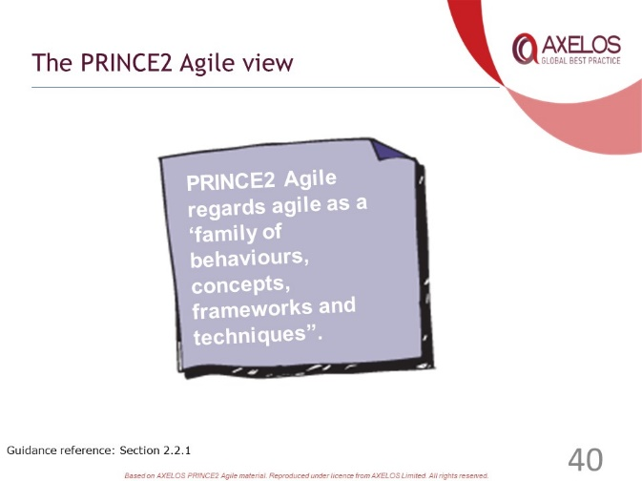 | ………………….………………………….……………………………..  ……………………….……………….…………………………………..  ………………………….……….………………………………………..  ………………….………….……………………………………………..  …………………………………..………………………………………..
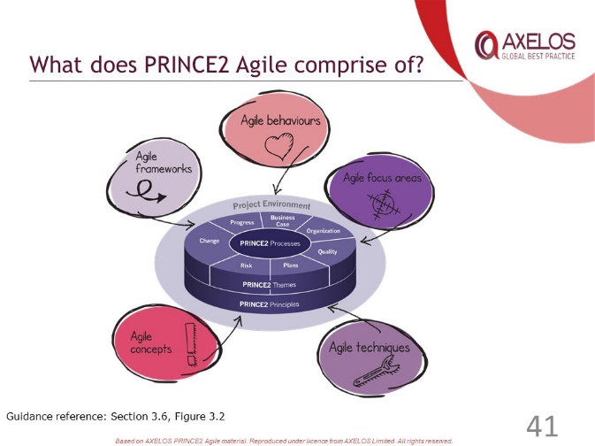 | ………………….………………………….……………………………..  ……………………….……………….…………………………………..  ………………………….……….………………………………………..  ………………….………….……………………………………………..  …………………………………..………………………………………..
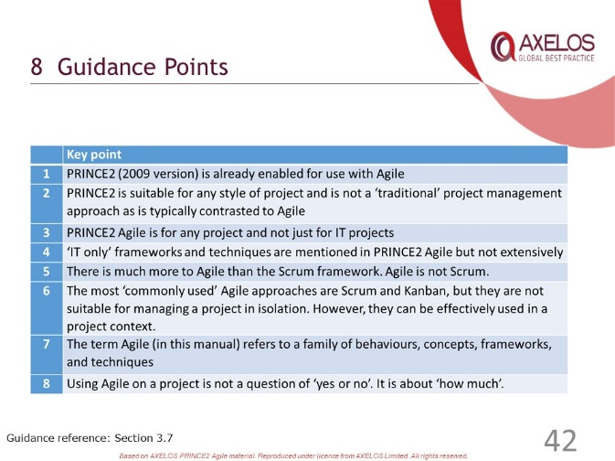 | ………………….………………………….……………………………..  ……………………….……………….…………………………………..  ………………………….……….………………………………………..  ………………….………….……………………………………………..  …………………………………..………………………………………..
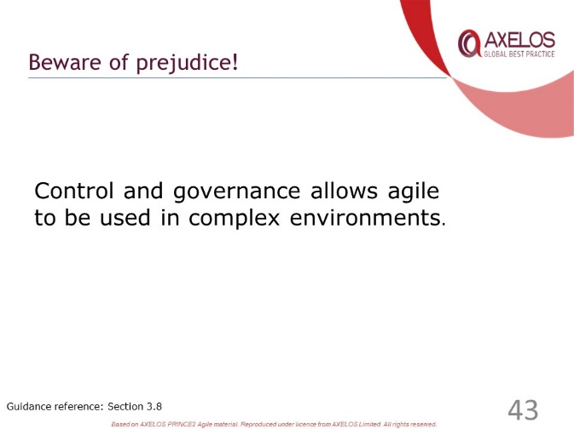 | ………………….………………………….……………………………..  ……………………….……………….…………………………………..  ………………………….……….………………………………………..  ………………….………….……………………………………………..  …………………………………..………………………………………..
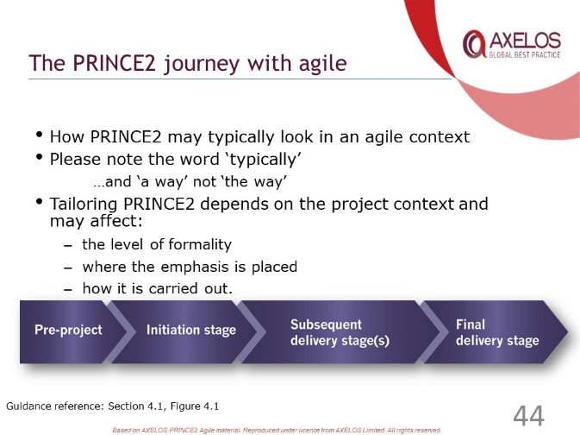 | ………………….………………………….……………………………..  ……………………….……………….…………………………………..  ………………………….……….………………………………………..  ………………….………….……………………………………………..  …………………………………..………………………………………..
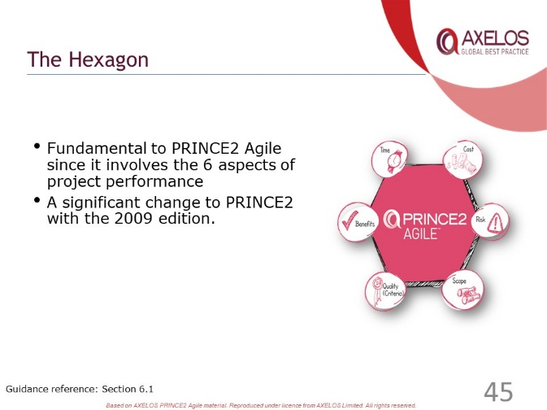 | ………………….………………………….……………………………..  ……………………….……………….…………………………………..  ………………………….……….………………………………………..  ………………….………….……………………………………………..  …………………………………..………………………………………..
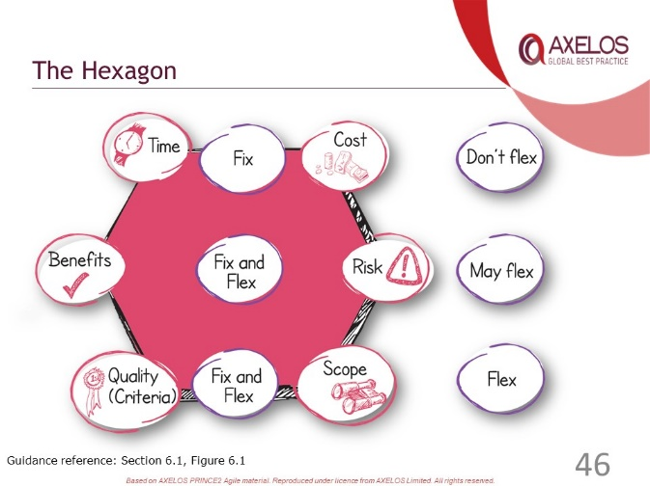 | ………………….………………………….……………………………..  ……………………….……………….…………………………………..  ………………………….……….………………………………………..  ………………….………….……………………………………………..  …………………………………..………………………………………..
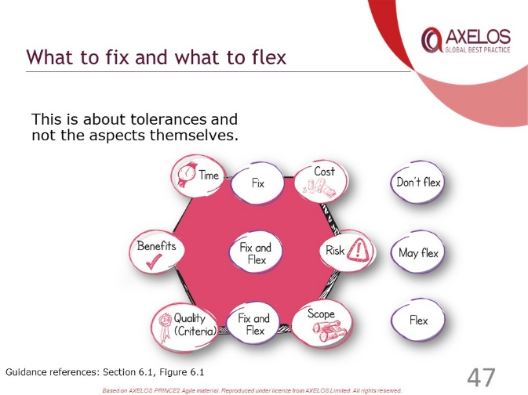 | ………………….………………………….……………………………..  ……………………….……………….…………………………………..  ………………………….……….………………………………………..  ………………….………….……………………………………………..  …………………………………..………………………………………..
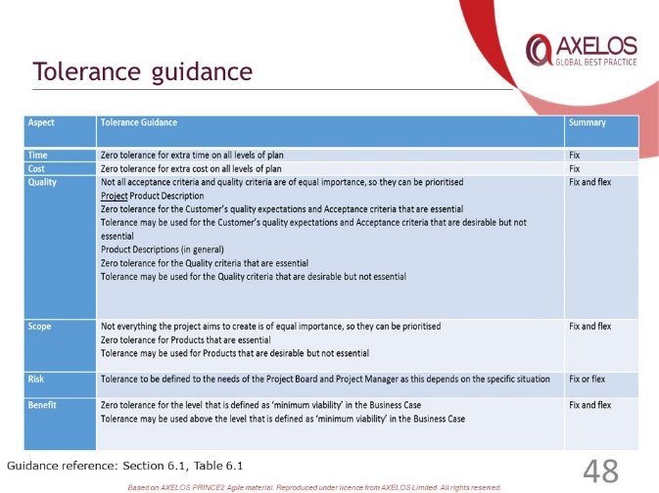 | ………………….………………………….……………………………..  ……………………….……………….…………………………………..  ………………………….……….………………………………………..  ………………….………….……………………………………………..  …………………………………..………………………………………..
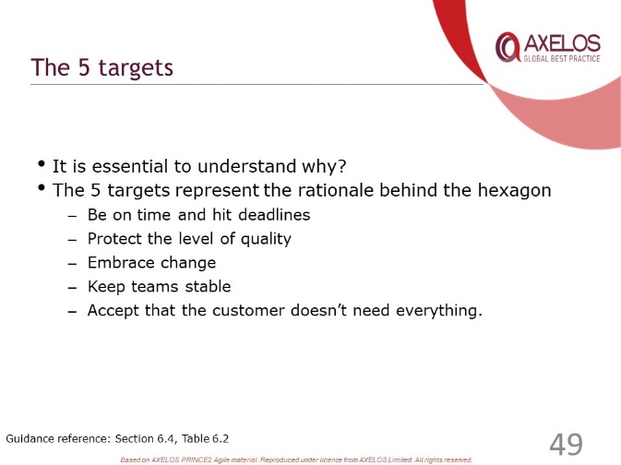 | ………………….………………………….……………………………..  ……………………….……………….…………………………………..  ………………………….……….………………………………………..  ………………….………….……………………………………………..  …………………………………..………………………………………..
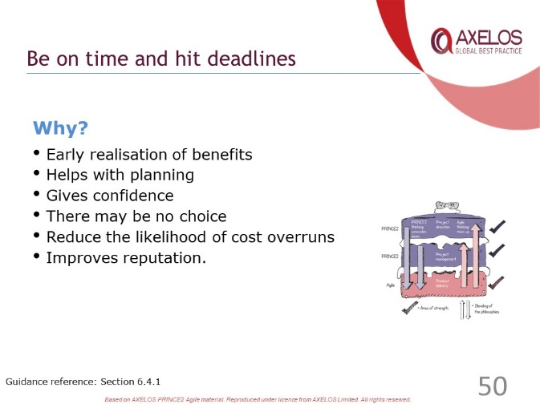 | ………………….………………………….……………………………..  ……………………….……………….…………………………………..  ………………………….……….………………………………………..  ………………….………….……………………………………………..  …………………………………..………………………………………..
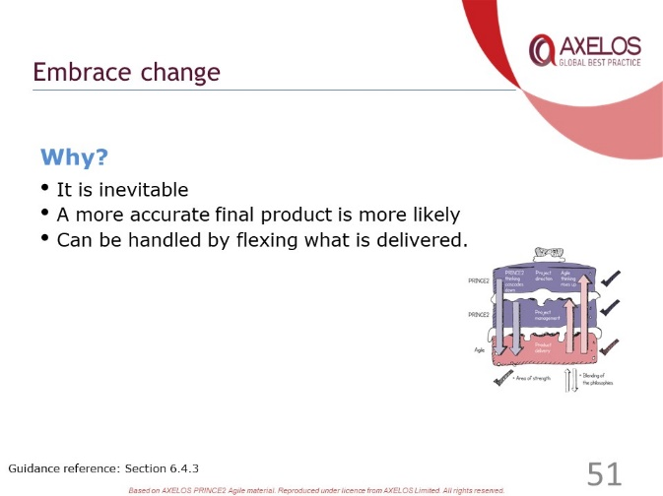 | ………………….………………………….……………………………..  ……………………….……………….…………………………………..  ………………………….……….………………………………………..  ………………….………….……………………………………………..  …………………………………..………………………………………..
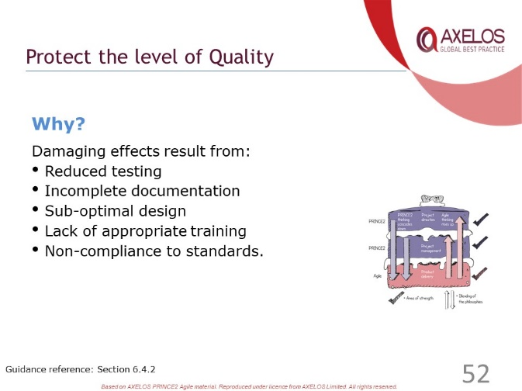 | ………………….………………………….……………………………..  ……………………….……………….…………………………………..  ………………………….……….………………………………………..  ………………….………….……………………………………………..  …………………………………..………………………………………..
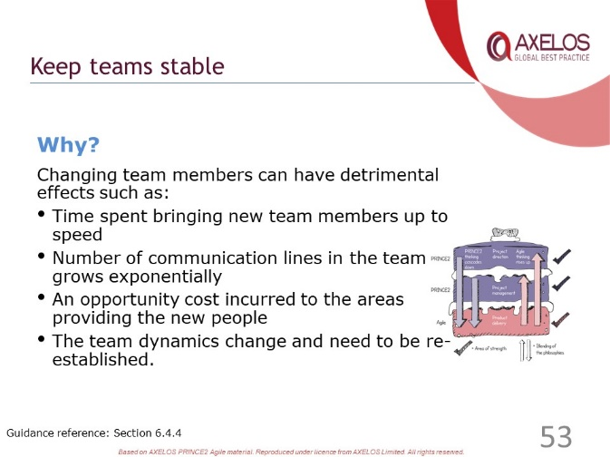 | ………………….………………………….……………………………..  ……………………….……………….…………………………………..  ………………………….……….………………………………………..  ………………….………….……………………………………………..  …………………………………..………………………………………..
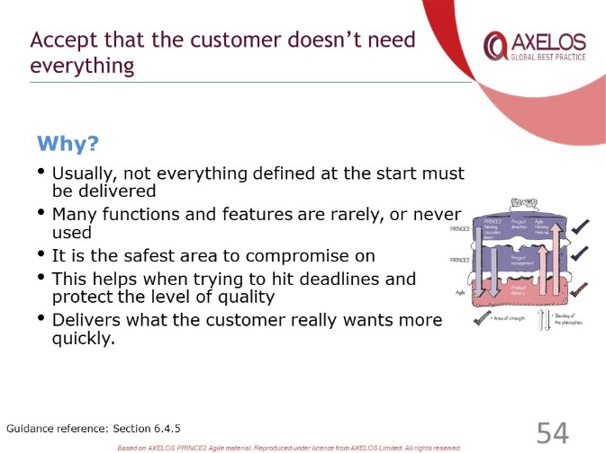 | ………………….………………………….……………………………..  ……………………….……………….…………………………………..  ………………………….……….………………………………………..  ………………….………….……………………………………………..  …………………………………..………………………………………..
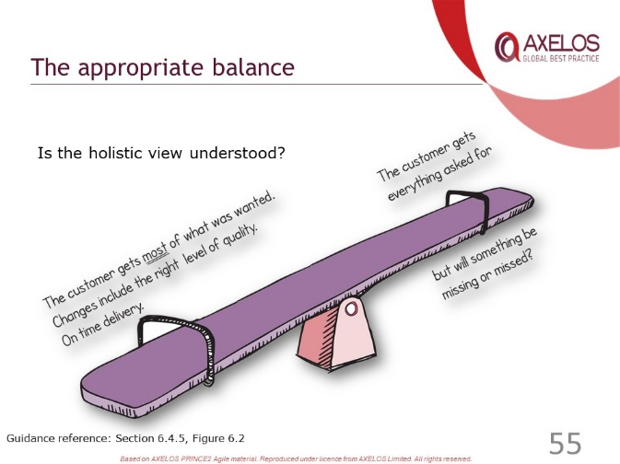 | ………………….………………………….……………………………..  ……………………….……………….…………………………………..  ………………………….……….………………………………………..  ………………….………….……………………………………………..  …………………………………..………………………………………..
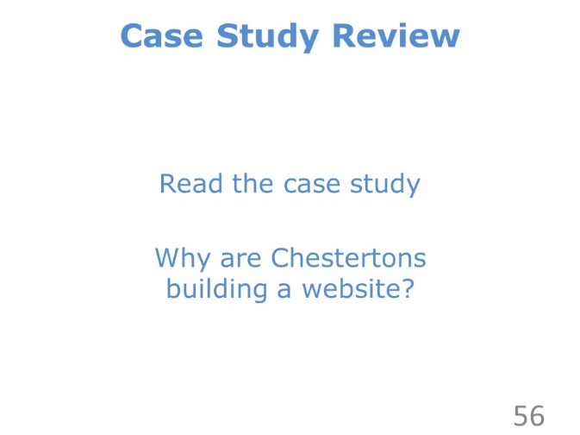 | ………………….………………………….……………………………..  ……………………….……………….…………………………………..  ………………………….……….………………………………………..  ………………….………….……………………………………………..  …………………………………..………………………………………..
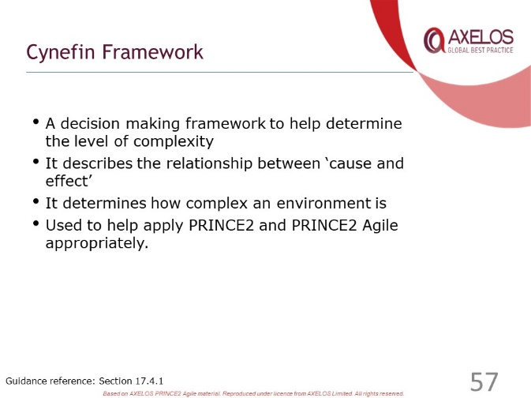 | ………………….………………………….……………………………..  ……………………….……………….…………………………………..  ………………………….……….………………………………………..  ………………….………….……………………………………………..  …………………………………..………………………………………..
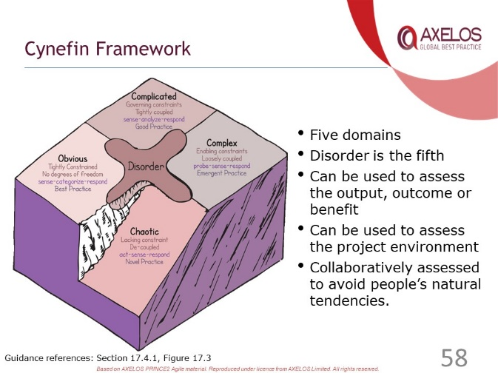 | ………………….………………………….……………………………..  ……………………….……………….…………………………………..  ………………………….……….………………………………………..  ………………….………….……………………………………………..  …………………………………..………………………………………..
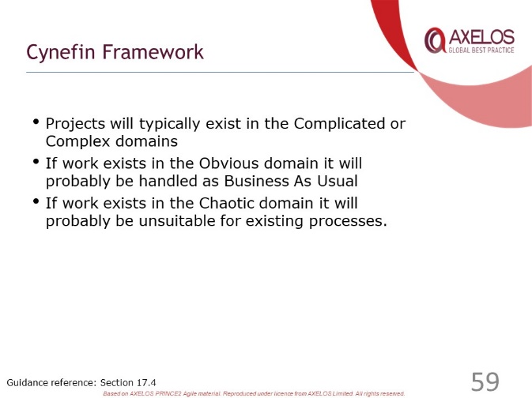 | ………………….………………………….……………………………..  ……………………….……………….…………………………………..  ………………………….……….………………………………………..  ………………….………….……………………………………………..  …………………………………..………………………………………..
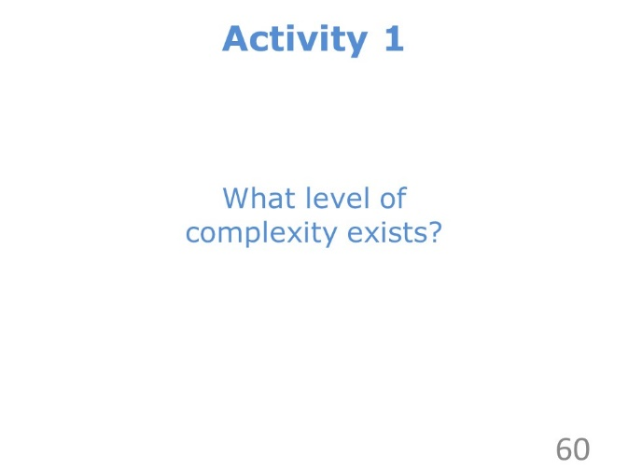 | ………………….………………………….……………………………..  ……………………….……………….…………………………………..  ………………………….……….………………………………………..  ………………….………….……………………………………………..  …………………………………..………………………………………..
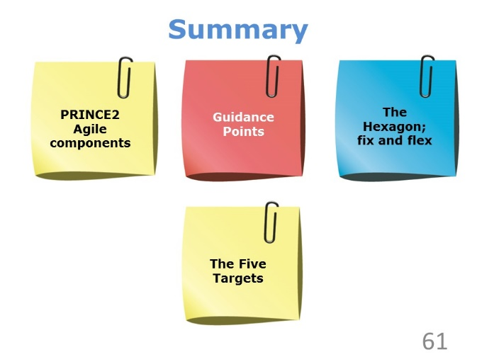 | ………………….………………………….……………………………..  ……………………….……………….…………………………………..  ………………………….……….………………………………………..  ………………….………….……………………………………………..  …………………………………..………………………………………..
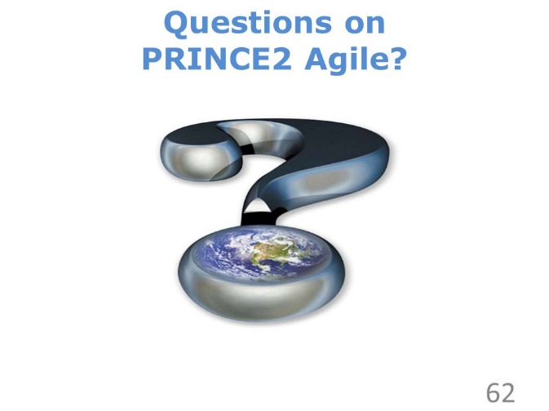 | ………………….………………………….……………………………..  ……………………….……………….…………………………………..  ………………………….……….………………………………………..  ………………….………….……………………………………………..  …………………………………..………………………………………..

Review Questions – PRINCE2 Agile

1 | Which of the following is not one of the five targets behind flexing what is delivered?  a) Embrace change  b) Be on time and hit deadlines  c) Accept that the customer doesn’t need everything  d) Demonstrate control
2 | Which statement best personifies PRINCE2 Agile?  a) Control and governance will reduce flexibility  b) Control and governance allow agile to be used in more complex projects  c) Control and governance ensure project success  d) Control and governance should be minimised in an agile environment
3 | Which of the following is a benefit of meeting the target “Protect the level of quality”  a) Reduce the likelihood of cost overruns  b) A more accurate final product is likely to be produced  c) Early delivery of the minimum viable product  d) Lower total cost of ownership of the final product
4 | Which of the following is not a domain in the Cynefin framework?  a) Confused  b) Complex  c) Chaotic  d) Complicated
5 | Which of the following statements does not align with PRINCE2 Agile’s approach to fixing and flexing?  a) Zero tolerance for extra time  b) Zero tolerance for products that are desirable  c) Zero tolerance for the customer’s essential acceptance criteria  d) Zero tolerance for the ‘minimum viability’ level defined in the Business Case

Check your answers with those on page 81.

Focus Areas

Slides
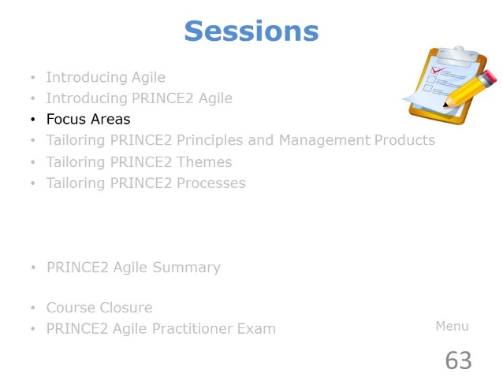 | ………………….………………………….……………………………..  ……………………….……………….…………………………………..  ………………………….……….………………………………………..  ………………….………….……………………………………………..  …………………………………..………………………………………..
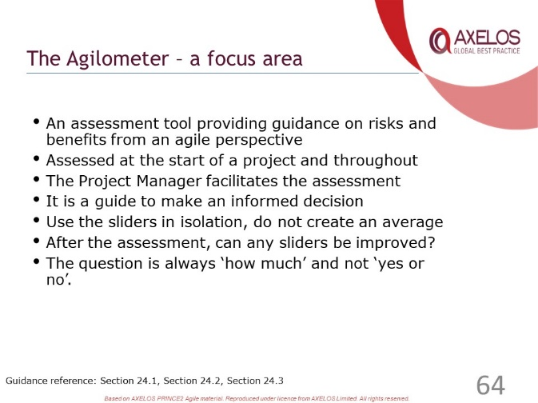 | ………………….………………………….……………………………..  ……………………….……………….…………………………………..  ………………………….……….………………………………………..  ………………….………….……………………………………………..  …………………………………..………………………………………..
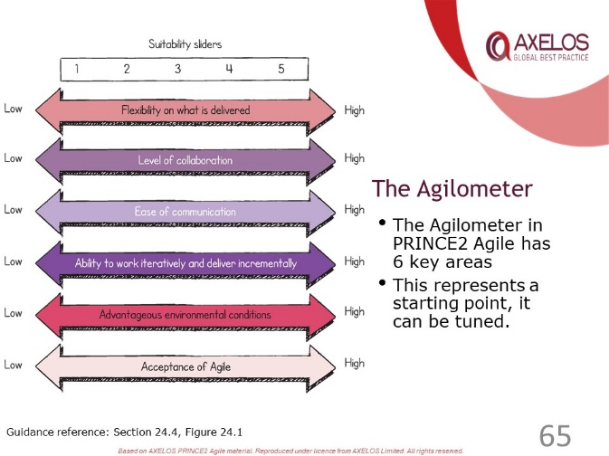 | ………………….………………………….……………………………..  ……………………….……………….…………………………………..  ………………………….……….………………………………………..  ………………….………….……………………………………………..  …………………………………..………………………………………..
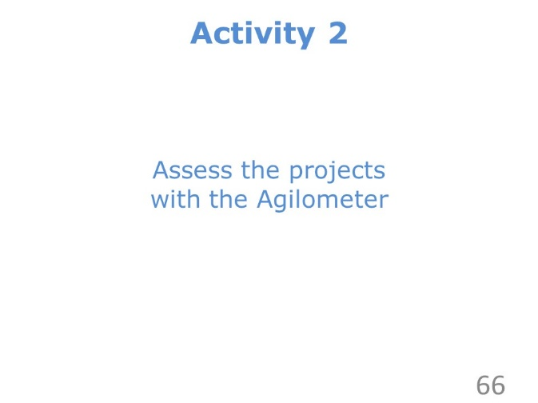 | ………………….………………………….……………………………..  ……………………….……………….…………………………………..  ………………………….……….………………………………………..  ………………….………….……………………………………………..  …………………………………..………………………………………..
………………….………………………….……………………………..

……………………….……………….…………………………………..

………………………….……….………………………………………..

………………….………….……………………………………………..

…………………………………..………………………………………..
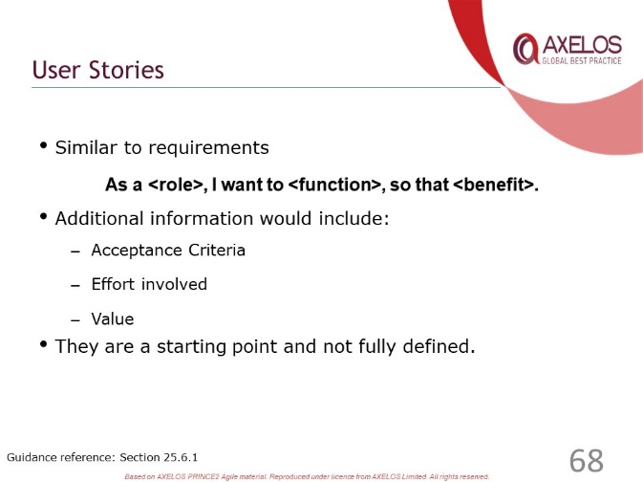 | ………………….………………………….……………………………..  ……………………….……………….…………………………………..  ………………………….……….………………………………………..  ………………….………….……………………………………………..  …………………………………..………………………………………..
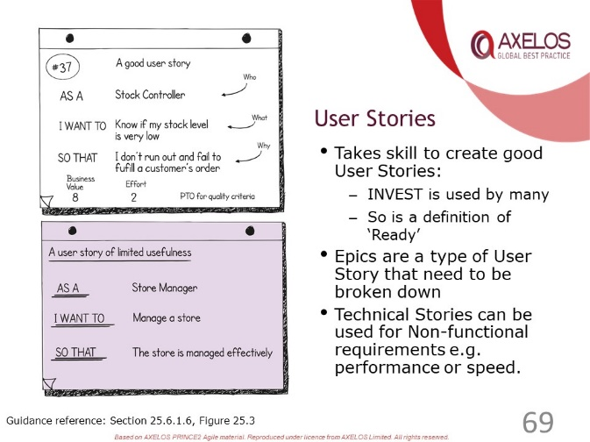 | ………………….………………………….……………………………..  ……………………….……………….…………………………………..  ………………………….……….………………………………………..  ………………….………….……………………………………………..  …………………………………..………………………………………..
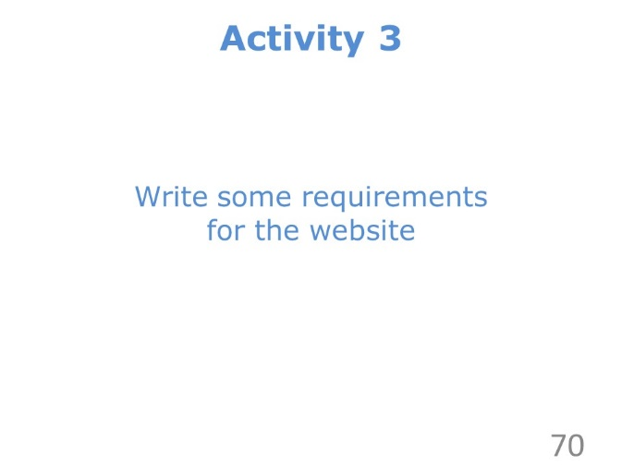 | ………………….………………………….……………………………..  ……………………….……………….…………………………………..  ………………………….……….………………………………………..  ………………….………….……………………………………………..  …………………………………..………………………………………..
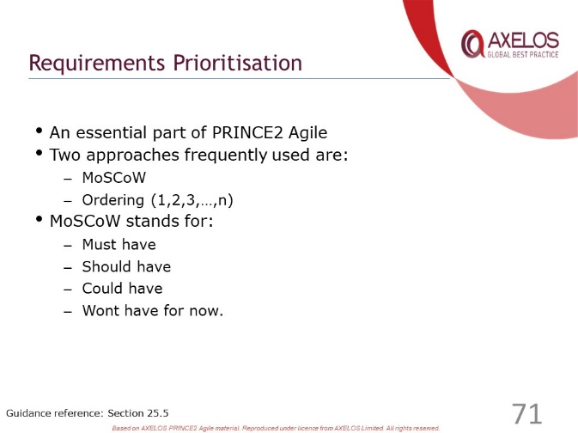 | ………………….………………………….……………………………..  ……………………….……………….…………………………………..  ………………………….……….………………………………………..  ………………….………….……………………………………………..  …………………………………..………………………………………..
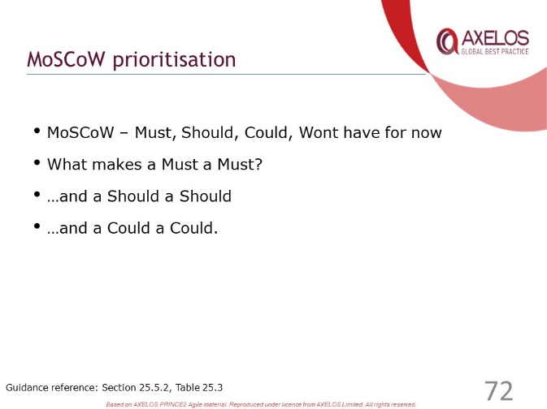 | ………………….………………………….……………………………..  ……………………….……………….…………………………………..  ………………………….……….………………………………………..  ………………….………….……………………………………………..  …………………………………..………………………………………..
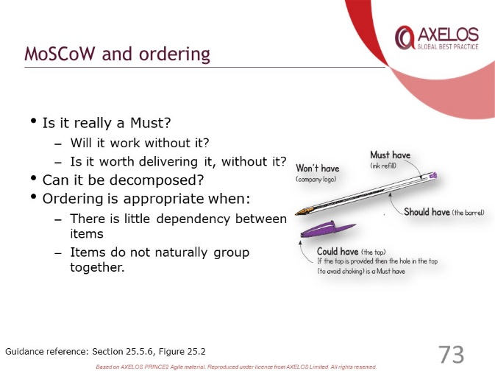 | ………………….………………………….……………………………..  ……………………….……………….…………………………………..  ………………………….……….………………………………………..  ………………….………….……………………………………………..  …………………………………..………………………………………..
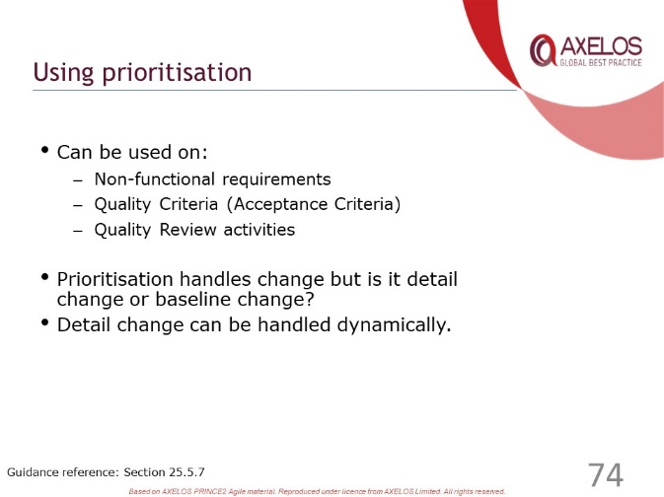 | ………………….………………………….……………………………..  ……………………….……………….…………………………………..  ………………………….……….………………………………………..  ………………….………….……………………………………………..  …………………………………..………………………………………..
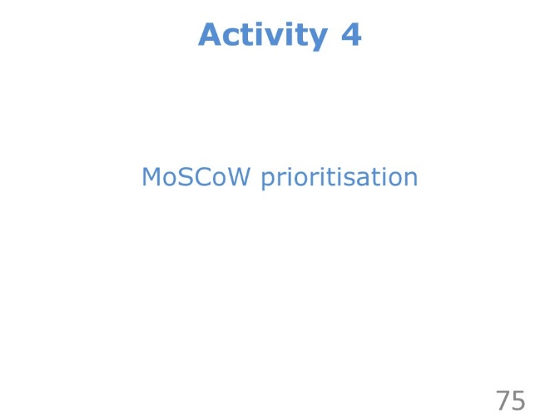 | ………………….………………………….……………………………..  ……………………….……………….…………………………………..  ………………………….……….………………………………………..  ………………….………….……………………………………………..  …………………………………..………………………………………..
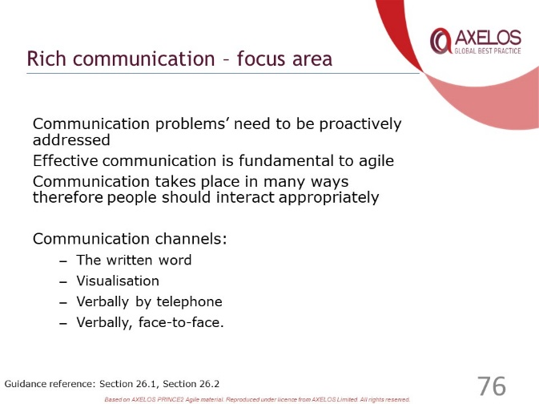 | ………………….………………………….……………………………..  ……………………….……………….…………………………………..  ………………………….……….………………………………………..  ………………….………….……………………………………………..  …………………………………..………………………………………..
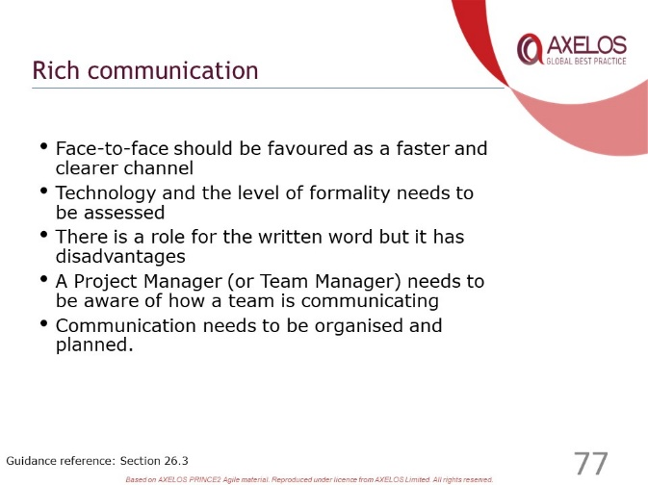 | ………………….………………………….……………………………..  ……………………….……………….…………………………………..  ………………………….……….………………………………………..  ………………….………….……………………………………………..  …………………………………..………………………………………..
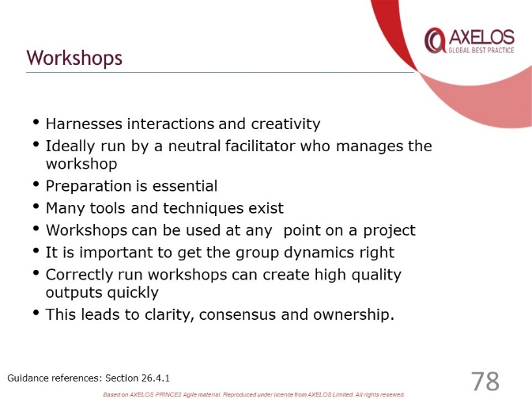 | ………………….………………………….……………………………..  ……………………….……………….…………………………………..  ………………………….……….………………………………………..  ………………….………….……………………………………………..  …………………………………..………………………………………..
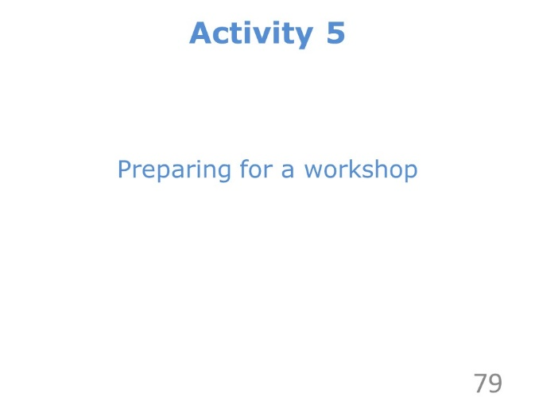 | ………………….………………………….……………………………..  ……………………….……………….…………………………………..  ………………………….……….………………………………………..  ………………….………….……………………………………………..  …………………………………..………………………………………..
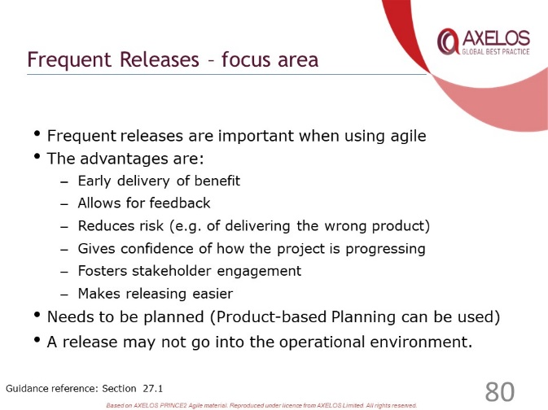 | ………………….………………………….……………………………..  ……………………….……………….…………………………………..  ………………………….……….………………………………………..  ………………….………….……………………………………………..  …………………………………..………………………………………..
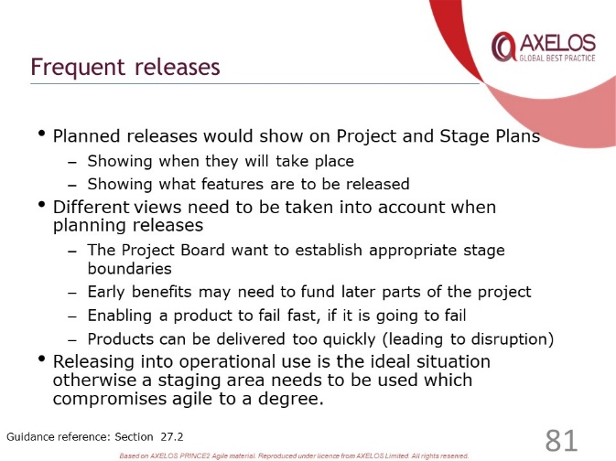 | ………………….………………………….……………………………..  ……………………….……………….…………………………………..  ………………………….……….………………………………………..  ………………….………….……………………………………………..  …………………………………..………………………………………..
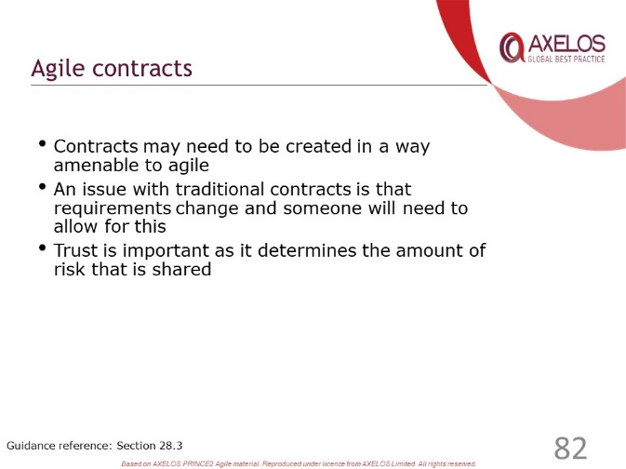 | ………………….………………………….……………………………..  ……………………….……………….…………………………………..  ………………………….……….………………………………………..  ………………….………….……………………………………………..  …………………………………..………………………………………..
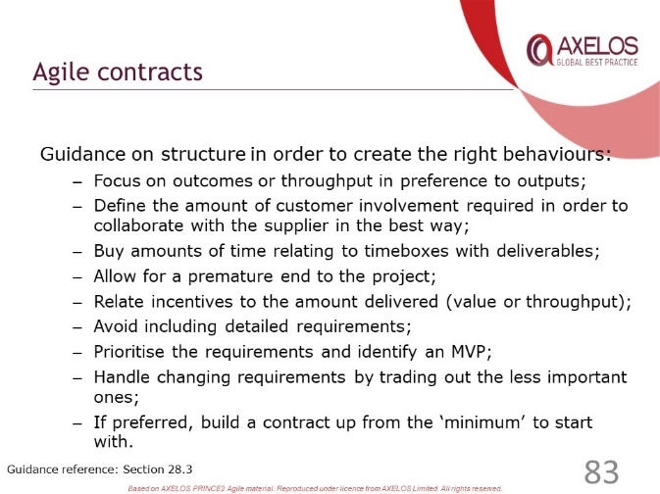 | ………………….………………………….……………………………..  ……………………….……………….…………………………………..  ………………………….……….………………………………………..  ………………….………….……………………………………………..  …………………………………..………………………………………..
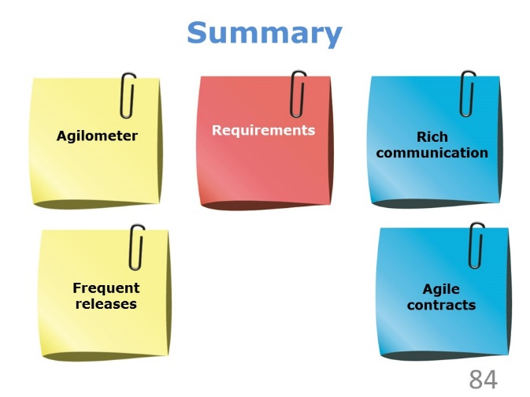 | ………………….………………………….……………………………..  ……………………….……………….…………………………………..  ………………………….……….………………………………………..  ………………….………….……………………………………………..  …………………………………..………………………………………..
………………….………………………….……………………………..

……………………….……………….…………………………………..

………………………….……….………………………………………..

………………….………….……………………………………………..

…………………………………..………………………………………..

Review Questions – Focus Areas

1 | Which of the following is not one of the suitability sliders on the Agilometer?  a) Level of collaboration  b) Ease of communication  c) Flexibility on what is to be delivered  d) Supportive team dynamics
2 | Where would you expect to find requirements at the highest level of details?  a) Product description  b) User story  c) Project product description  d) Work Package
3 | Which of the following is not an advantage of frequent releases?  a) Fosters engagement with project stakeholders  b) Enables early delivery of benefit to the customer  c) Increases confidence about the project through evidence  d) The project can finish faster
4 | Which of these are identified in PRINCE2 Agile as possible workshop techniques?  1) Prioritisation with dots  2) Visioning  3) Brainstorming  4) The five whys  a) None of the four  b) Only the third  c) Only the first  d) All four
5 | What does PRINCE2 Agile say about contracts?  a) A contract needs to support collaborative ways of working  b) A contingency premium should be added to the contract price  c) The contract should focus on the solution  d) The supplier must satisfy all requirements

Check your answers with those on page 81.

Tailoring PRINCE2 Principles and Management Products

Slides
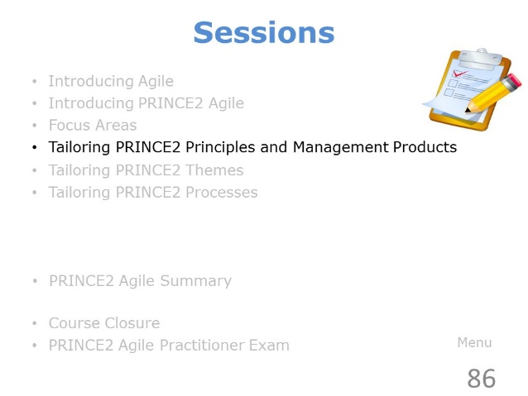 | ………………….………………………….……………………………..  ……………………….……………….…………………………………..  ………………………….……….………………………………………..  ………………….………….……………………………………………..  …………………………………..………………………………………..
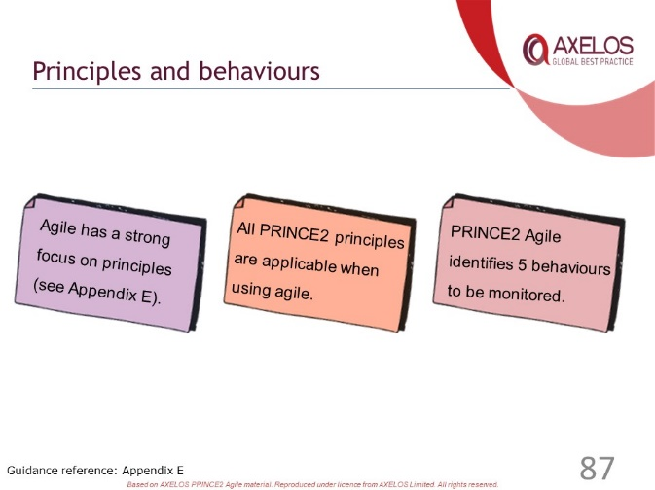 | ………………….………………………….……………………………..  ……………………….……………….…………………………………..  ………………………….……….………………………………………..  ………………….………….……………………………………………..  …………………………………..………………………………………..
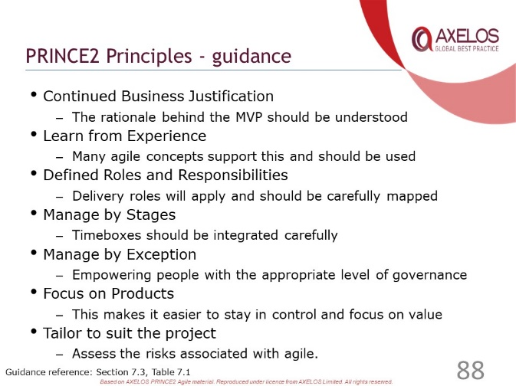 | ………………….………………………….……………………………..  ……………………….……………….…………………………………..  ………………………….……….………………………………………..  ………………….………….……………………………………………..  …………………………………..………………………………………..
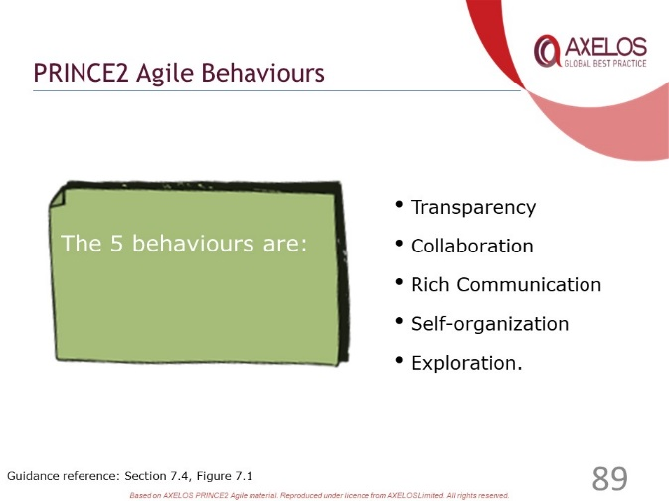 | ………………….………………………….……………………………..  ……………………….……………….…………………………………..  ………………………….……….………………………………………..  ………………….………….……………………………………………..  …………………………………..………………………………………..
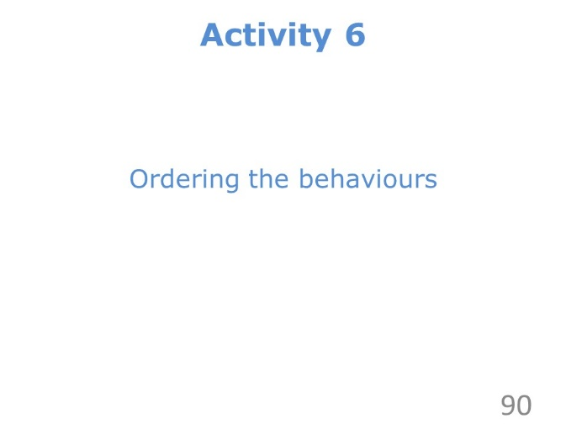 | ………………….………………………….……………………………..  ……………………….……………….…………………………………..  ………………………….……….………………………………………..  ………………….………….……………………………………………..  …………………………………..………………………………………..
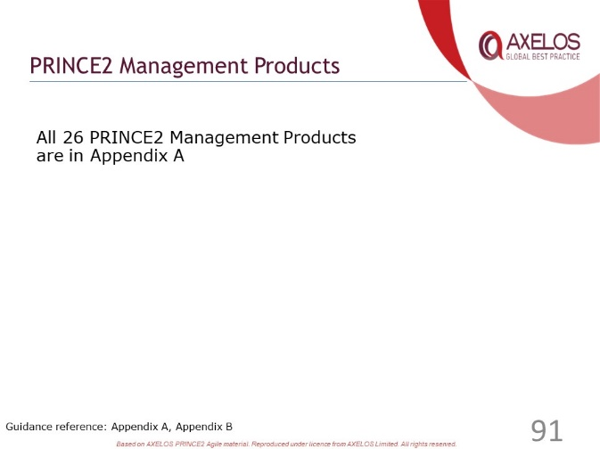 | ………………….………………………….……………………………..  ……………………….……………….…………………………………..  ………………………….……….………………………………………..  ………………….………….……………………………………………..  …………………………………..………………………………………..
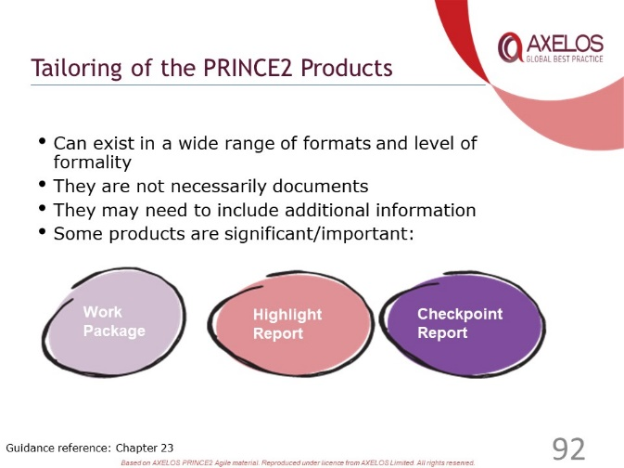 | ………………….………………………….……………………………..  ……………………….……………….…………………………………..  ………………………….……….………………………………………..  ………………….………….……………………………………………..  …………………………………..………………………………………..
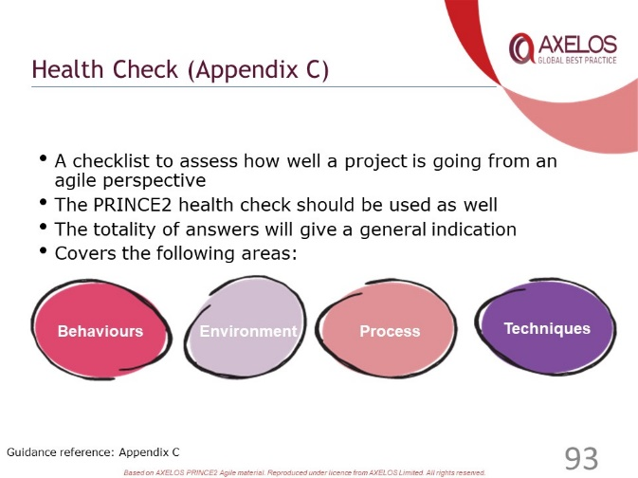 | ………………….………………………….……………………………..  ……………………….……………….…………………………………..  ………………………….……….………………………………………..  ………………….………….……………………………………………..  …………………………………..………………………………………..
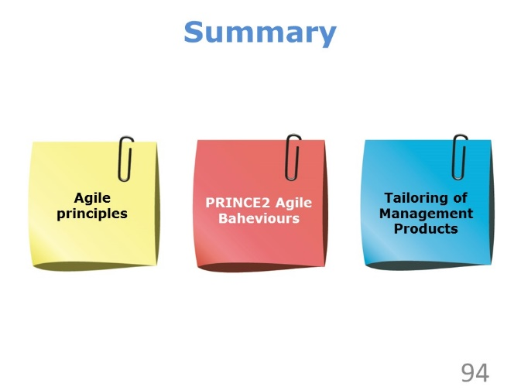 | ………………….………………………….……………………………..  ……………………….……………….…………………………………..  ………………………….……….………………………………………..  ………………….………….……………………………………………..  …………………………………..………………………………………..
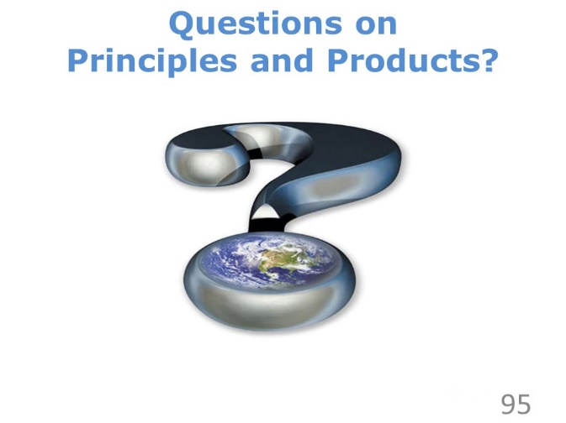 | ………………….………………………….……………………………..  ……………………….……………….…………………………………..  ………………………….……….………………………………………..  ………………….………….……………………………………………..  …………………………………..………………………………………..

Review Questions – Principles and Products

1 | Which of these are PRINCE2 Agile behaviours?  1) Prioritisation  2) Transparency  3) Collaboration  4) Exploration  a) Only the first, third and fourth are true  b) Only the third and fourth are true  c) All four are true  d) Only the second, third and fourth are true
2 | When does the Manage by Stages principle suggest that many short stages could be useful?  a) When management control must be increased  b) When creating something very innovative  c) When planning large stages would be too expensive  d) To improve the viability of the Business Case
3 | In which PRINCE2 management product would you expect to find the minimum viable product identified?  a) The Business Case  b) The Project Product Description  c) A product Description  d) A Stage Plan
4 | Which of the following derives from the Exploration behaviour?  a) Self-organising creates mutual respect  b) Using visualisation can be more effective than words on their own  c) Learning helps to improve the products  d) Openness is an essential ingredient of an agile way of working
5 | What is not one of the forms in which PRINCE2 Agile suggests that a Checkpoint Report could be presented?  a) A burn chart  b) A daily stand-up or Scrum meeting  c) A formal document  d) An information radiator

Check your answers with those on page 81.

Tailoring PRINCE2 Themes

Slides
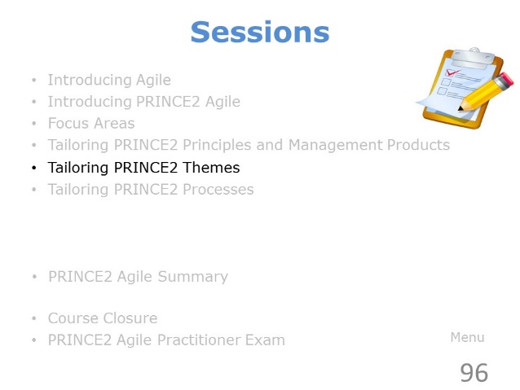 | ………………….………………………….……………………………..  ……………………….……………….…………………………………..  ………………………….……….………………………………………..  ………………….………….……………………………………………..  …………………………………..………………………………………..
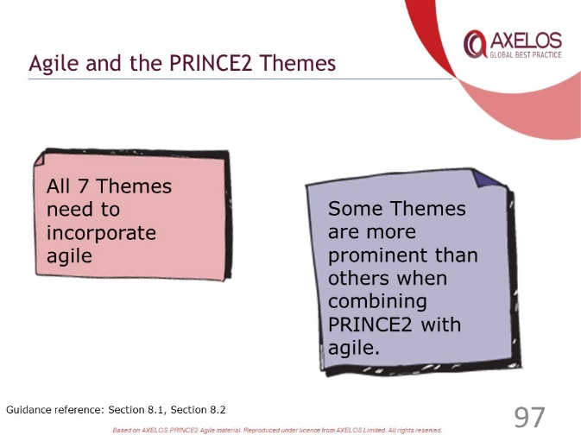 | ………………….………………………….……………………………..  ……………………….……………….…………………………………..  ………………………….……….………………………………………..  ………………….………….……………………………………………..  …………………………………..………………………………………..
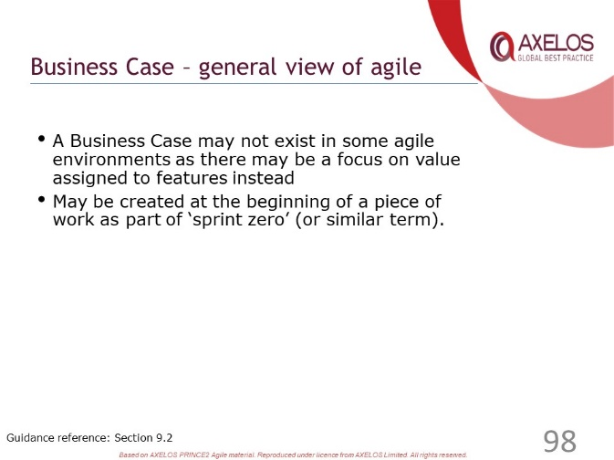 | ………………….………………………….……………………………..  ……………………….……………….…………………………………..  ………………………….……….………………………………………..  ………………….………….……………………………………………..  …………………………………..………………………………………..
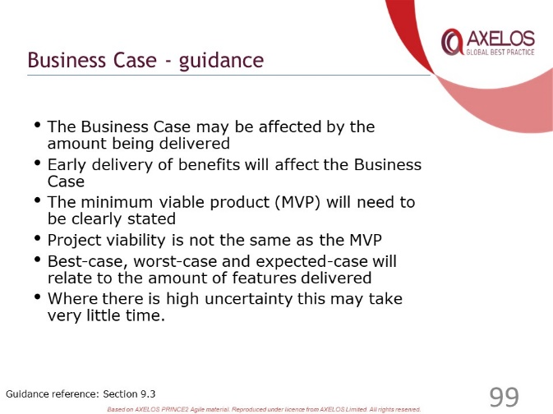 | ………………….………………………….……………………………..  ……………………….……………….…………………………………..  ………………………….……….………………………………………..  ………………….………….……………………………………………..  …………………………………..………………………………………..
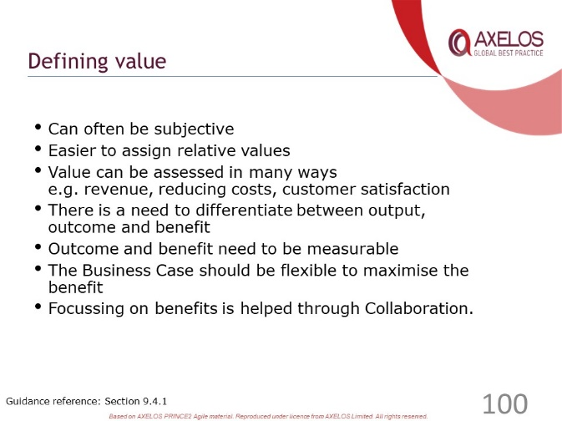 | ………………….………………………….……………………………..  ……………………….……………….…………………………………..  ………………………….……….………………………………………..  ………………….………….……………………………………………..  …………………………………..………………………………………..
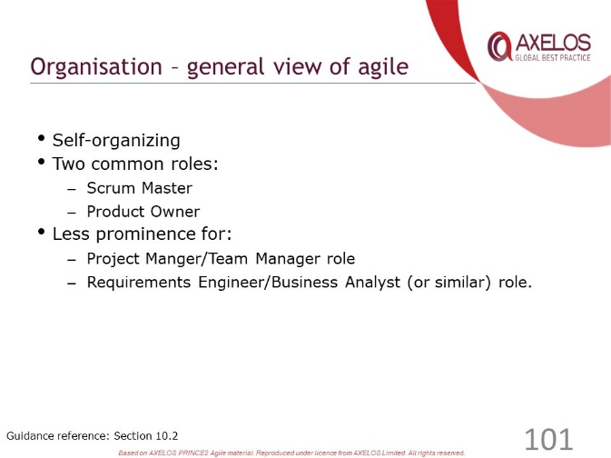 | ………………….………………………….……………………………..  ……………………….……………….…………………………………..  ………………………….……….………………………………………..  ………………….………….……………………………………………..  …………………………………..………………………………………..
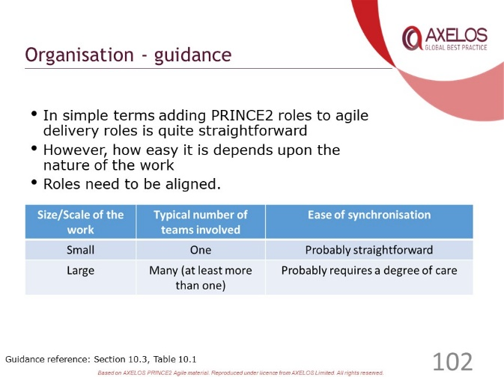 | ………………….………………………….……………………………..  ……………………….……………….…………………………………..  ………………………….……….………………………………………..  ………………….………….……………………………………………..  …………………………………..………………………………………..
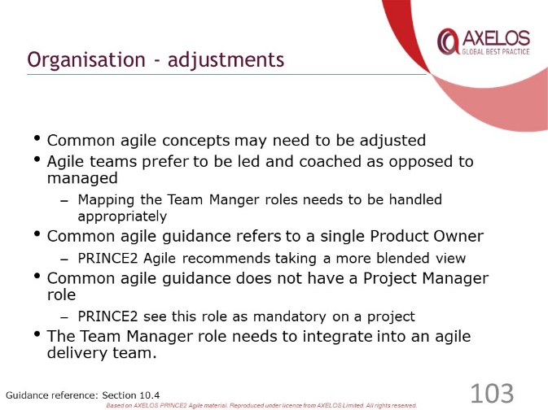 | ………………….………………………….……………………………..  ……………………….……………….…………………………………..  ………………………….……….………………………………………..  ………………….………….……………………………………………..  …………………………………..………………………………………..
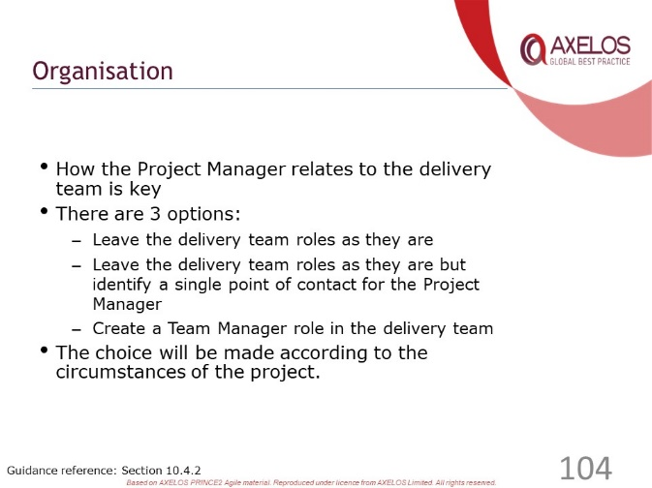 | ………………….………………………….……………………………..  ……………………….……………….…………………………………..  ………………………….……….………………………………………..  ………………….………….……………………………………………..  …………………………………..………………………………………..
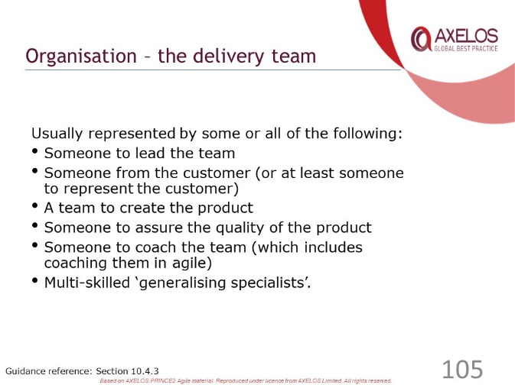 | ………………….………………………….……………………………..  ……………………….……………….…………………………………..  ………………………….……….………………………………………..  ………………….………….……………………………………………..  …………………………………..………………………………………..
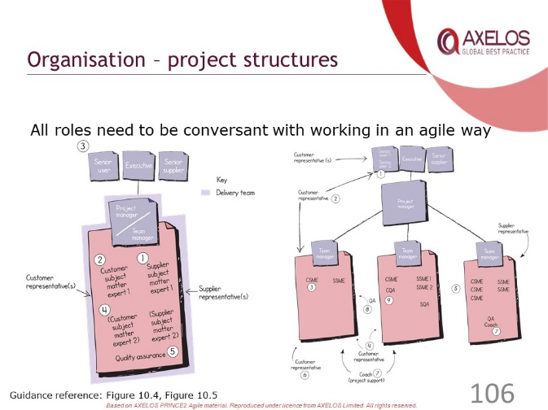 | ………………….………………………….……………………………..  ……………………….……………….…………………………………..  ………………………….……….………………………………………..  ………………….………….……………………………………………..  …………………………………..………………………………………..
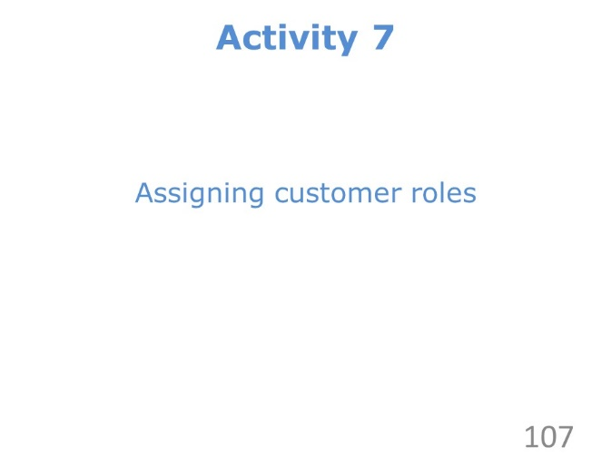 | ………………….………………………….……………………………..  ……………………….……………….…………………………………..  ………………………….……….………………………………………..  ………………….………….……………………………………………..  …………………………………..………………………………………..
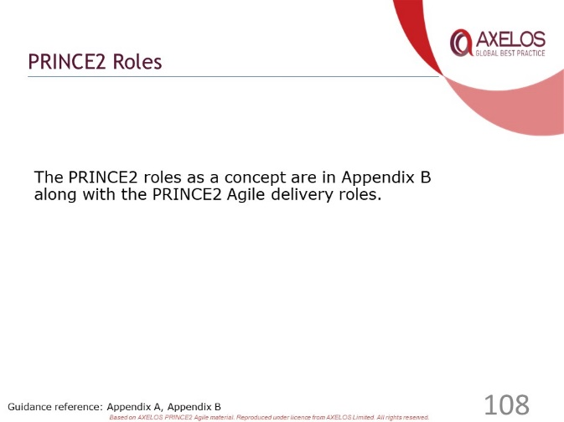 | ………………….………………………….……………………………..  ……………………….……………….…………………………………..  ………………………….……….………………………………………..  ………………….………….……………………………………………..  …………………………………..………………………………………..
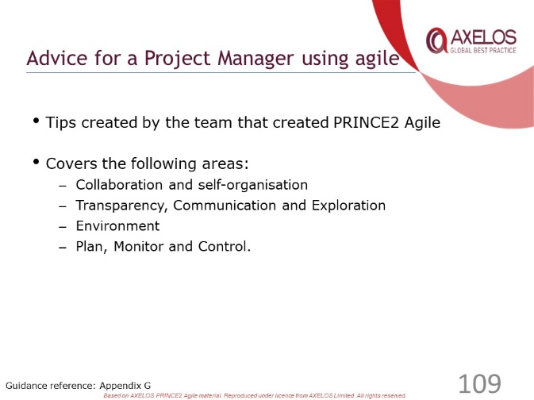 | ………………….………………………….……………………………..  ……………………….……………….…………………………………..  ………………………….……….………………………………………..  ………………….………….……………………………………………..  …………………………………..………………………………………..
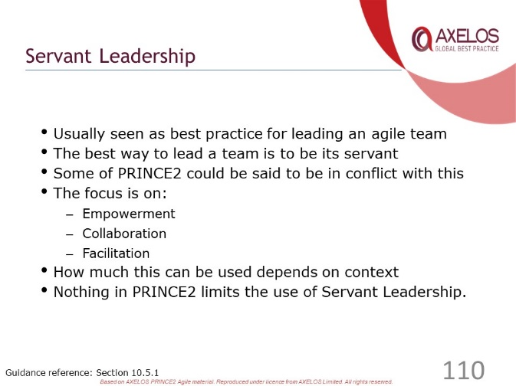 | ………………….………………………….……………………………..  ……………………….……………….…………………………………..  ………………………….……….………………………………………..  ………………….………….……………………………………………..  …………………………………..………………………………………..
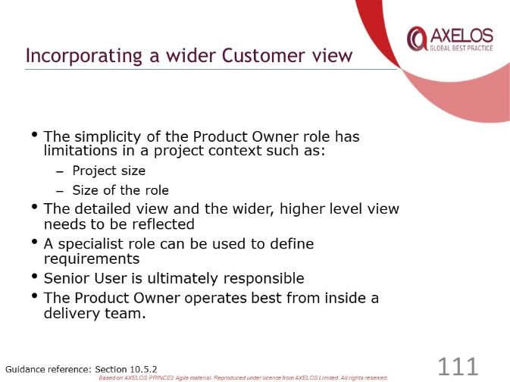 | ………………….………………………….……………………………..  ……………………….……………….…………………………………..  ………………………….……….………………………………………..  ………………….………….……………………………………………..  …………………………………..………………………………………..
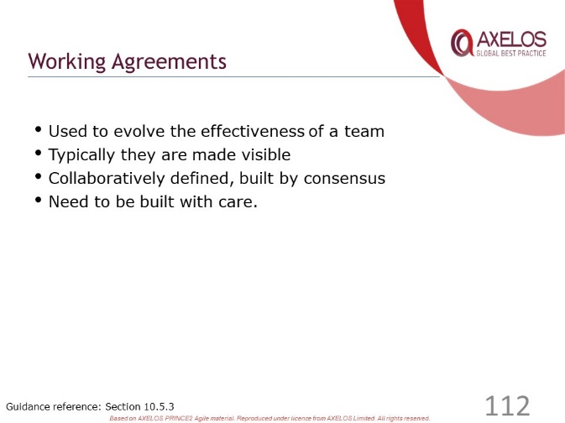 | ………………….………………………….……………………………..  ……………………….……………….…………………………………..  ………………………….……….………………………………………..  ………………….………….……………………………………………..  …………………………………..………………………………………..
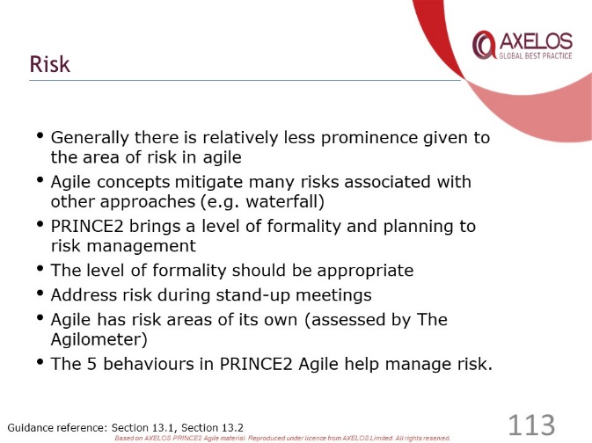 | ………………….………………………….……………………………..  ……………………….……………….…………………………………..  ………………………….……….………………………………………..  ………………….………….……………………………………………..  …………………………………..………………………………………..
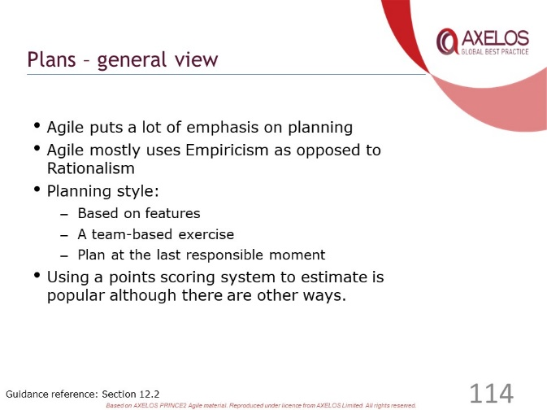 | ………………….………………………….……………………………..  ……………………….……………….…………………………………..  ………………………….……….………………………………………..  ………………….………….……………………………………………..  …………………………………..………………………………………..
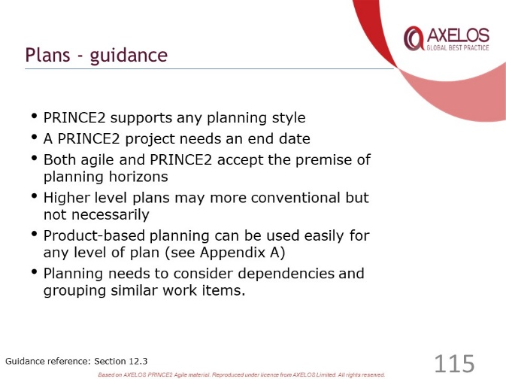 | ………………….………………………….……………………………..  ……………………….……………….…………………………………..  ………………………….……….………………………………………..  ………………….………….……………………………………………..  …………………………………..………………………………………..
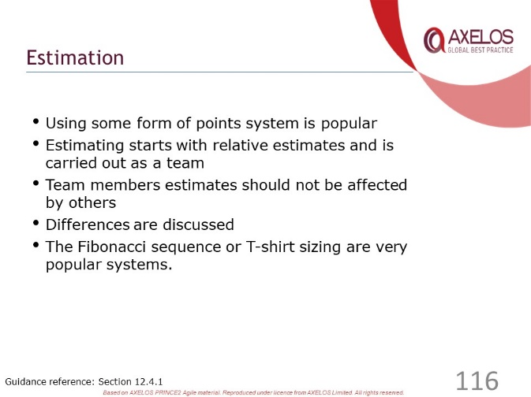 | ………………….………………………….……………………………..  ……………………….……………….…………………………………..  ………………………….……….………………………………………..  ………………….………….……………………………………………..  …………………………………..………………………………………..
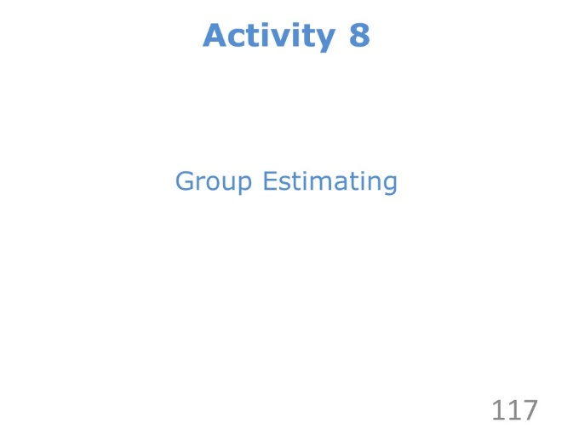 | ………………….………………………….……………………………..  ……………………….……………….…………………………………..  ………………………….……….………………………………………..  ………………….………….……………………………………………..  …………………………………..………………………………………..
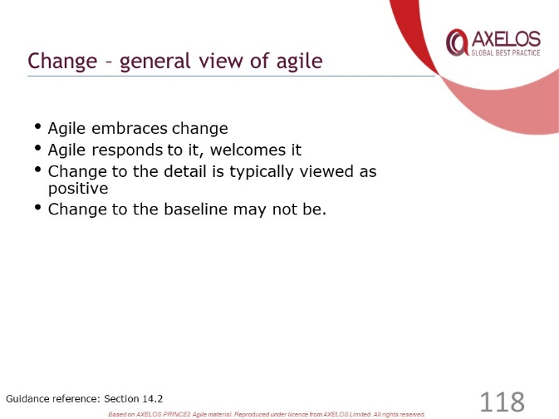 | ………………….………………………….……………………………..  ……………………….……………….…………………………………..  ………………………….……….………………………………………..  ………………….………….……………………………………………..  …………………………………..………………………………………..
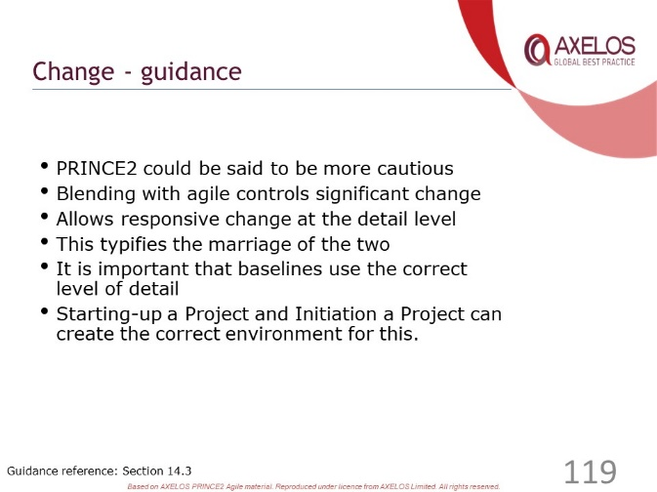 | ………………….………………………….……………………………..  ……………………….……………….…………………………………..  ………………………….……….………………………………………..  ………………….………….……………………………………………..  …………………………………..………………………………………..
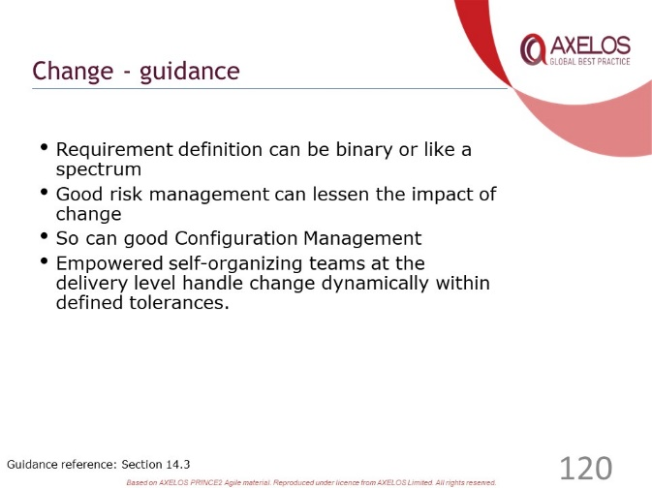 | ………………….………………………….……………………………..  ……………………….……………….…………………………………..  ………………………….……….………………………………………..  ………………….………….……………………………………………..  …………………………………..………………………………………..
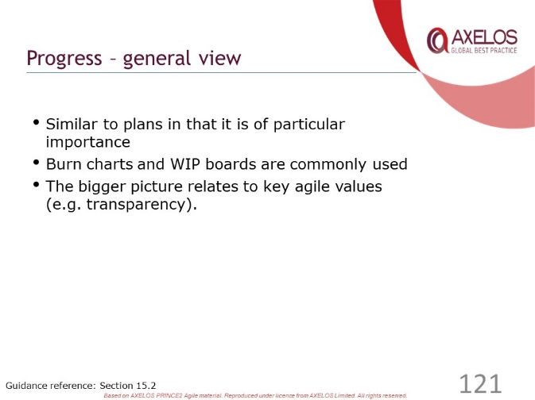 | ………………….………………………….……………………………..  ……………………….……………….…………………………………..  ………………………….……….………………………………………..  ………………….………….……………………………………………..  …………………………………..………………………………………..
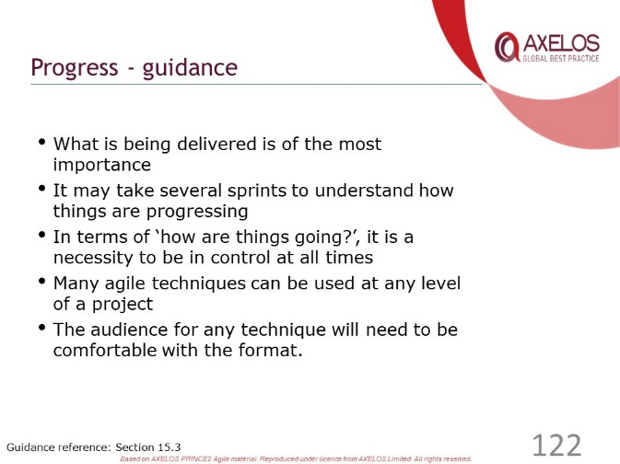 | ………………….………………………….……………………………..  ……………………….……………….…………………………………..  ………………………….……….………………………………………..  ………………….………….……………………………………………..  …………………………………..………………………………………..
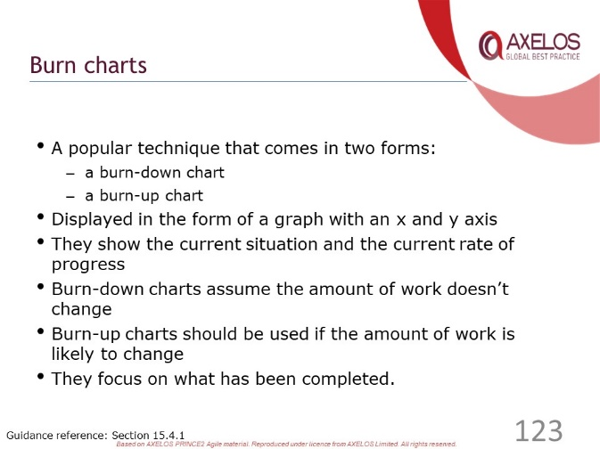 | ………………….………………………….……………………………..  ……………………….……………….…………………………………..  ………………………….……….………………………………………..  ………………….………….……………………………………………..  …………………………………..………………………………………..
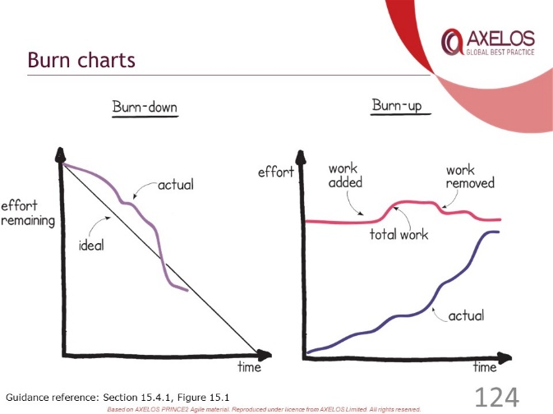 | ………………….………………………….……………………………..  ……………………….……………….…………………………………..  ………………………….……….………………………………………..  ………………….………….……………………………………………..  …………………………………..………………………………………..
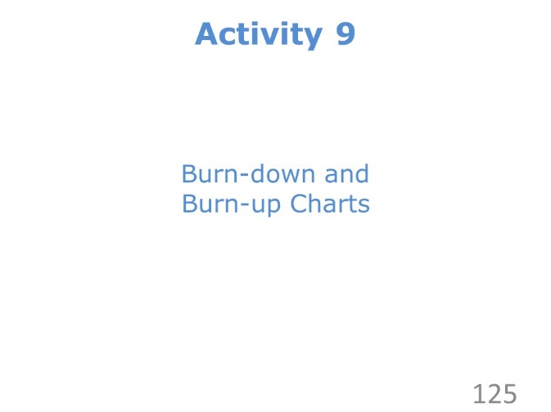 | ………………….………………………….……………………………..  ……………………….……………….…………………………………..  ………………………….……….………………………………………..  ………………….………….……………………………………………..  …………………………………..………………………………………..
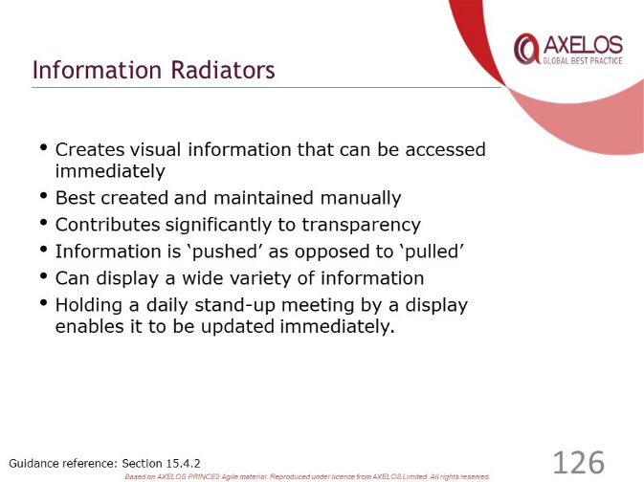 | ………………….………………………….……………………………..  ……………………….……………….…………………………………..  ………………………….……….………………………………………..  ………………….………….……………………………………………..  …………………………………..………………………………………..
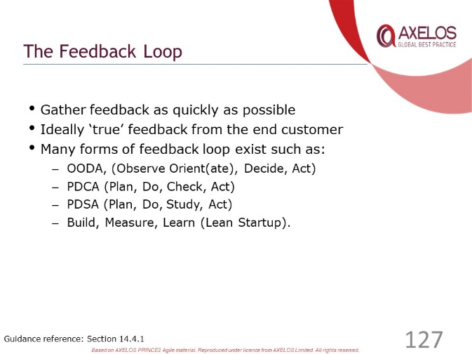 | ………………….………………………….……………………………..  ……………………….……………….…………………………………..  ………………………….……….………………………………………..  ………………….………….……………………………………………..  …………………………………..………………………………………..
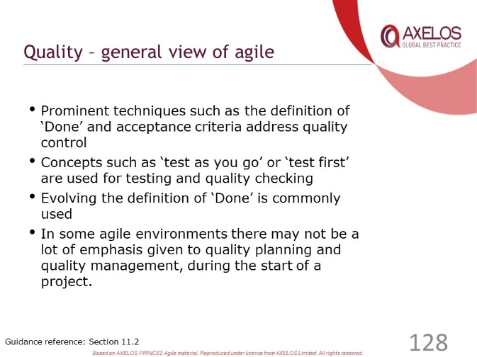 | ………………….………………………….……………………………..  ……………………….……………….…………………………………..  ………………………….……….………………………………………..  ………………….………….……………………………………………..  …………………………………..………………………………………..
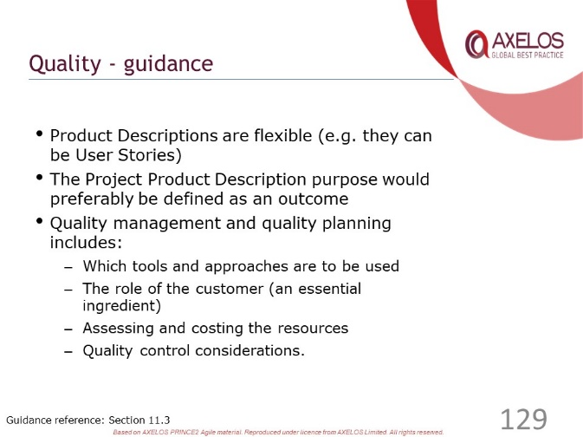 | ………………….………………………….……………………………..  ……………………….……………….…………………………………..  ………………………….……….………………………………………..  ………………….………….……………………………………………..  …………………………………..………………………………………..
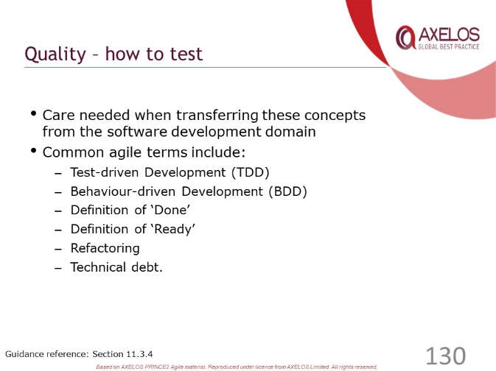 | ………………….………………………….……………………………..  ……………………….……………….…………………………………..  ………………………….……….………………………………………..  ………………….………….……………………………………………..  …………………………………..………………………………………..
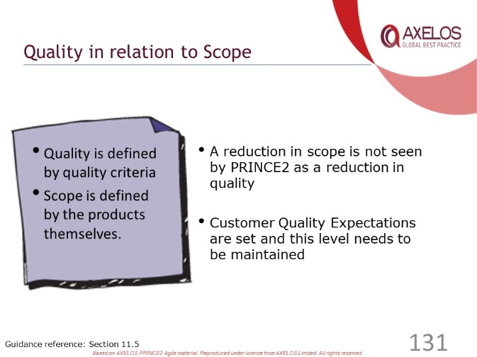 | ………………….………………………….……………………………..  ……………………….……………….…………………………………..  ………………………….……….………………………………………..  ………………….………….……………………………………………..  …………………………………..………………………………………..
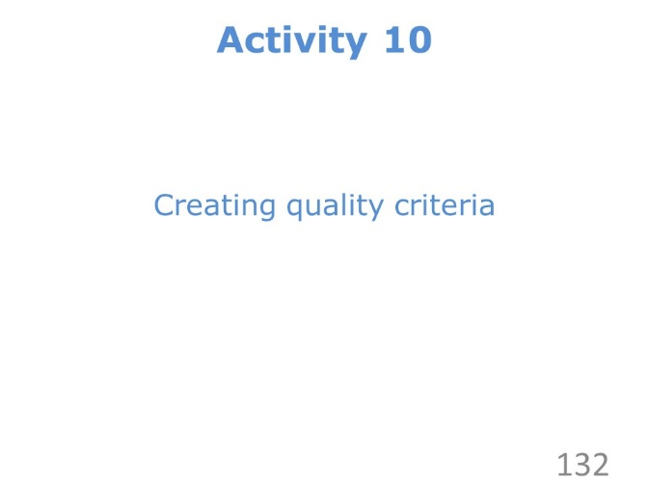 | ………………….………………………….……………………………..  ……………………….……………….…………………………………..  ………………………….……….………………………………………..  ………………….………….……………………………………………..  …………………………………..………………………………………..
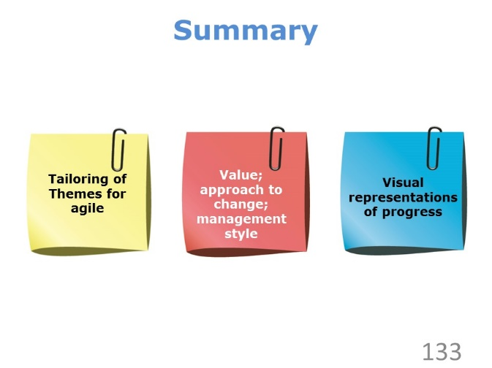 | ………………….………………………….……………………………..  ……………………….……………….…………………………………..  ………………………….……….………………………………………..  ………………….………….……………………………………………..  …………………………………..………………………………………..
………………….………………………….……………………………..

……………………….……………….…………………………………..

………………………….……….………………………………………..

………………….………….……………………………………………..

…………………………………..………………………………………..

Review Questions – Themes

1 | If there is one day of work remaining on a 10 day task, how should this be reflected on a burn-down chart?  a) The task should be shown as 10% complete  b) The task should be marked as complete because it will be completed  tomorrow  c) The burn-down chart should not be updated until the task meets the  definition of done  d) The actual line should be one day above the ideal line
2 | The Project Product Description includes the following acceptance criteria for some training materials: “It must be possible for the training materials to be maintained in the future. The training materials must be usable for future training events”. Which reason explains why the team should protect the level of quality in relation to the acceptance criteria?  a) They should be delivered as the minimum viable product  b) They should ensure that the cost of owning the training materials is  acceptable  c) They should be made transparent for future maintenance  d) They should be tested using spikes to trial the maintenance procedures
3 | The Project Manager has asked the Scrum Master who will be leading one of the work streams to act as Team Manager. The Team manager will act as a single point of contact for the Project Manager. The Team Manager will continue to coach the team. Which of the following BEST describes how this tailors the Organisation theme?  a) The Project Manager wants the team to use fewer agile behaviours than  they are currently using  b) Each person in the team, including the Scrum Master, should be capable  of performing multiple roles  c) There should only be one team in a small project, with the team taking  on all of the delivery roles  d) The Scrum Master should act as a servant-leader while carrying out the  responsibilities of a Team Manager
4 | A team is concerned about a particular risk originating outside the organisation. The Team Manager has asked the Business Analyst to investigate this risk and report back to the team at the next daily stand-up. Which of the following BEST explains how this approach manages risk?  a) It is a poor approach because the risk is outside the team’s control  b) It is a poor approach because the Team Manager should carry out  all risk actions  c) It is a good approach because the Business Analyst is responsible  for capturing the wider customer view  d) It is a good approach because discussions in the daily stand-up  are a way to actively manage risk
5 | A timebox includes three high-level requirements. During timebox planning, it was identified that it would not be possible to deliver all three of these requirements during the timebox. What is the effect of setting the time tolerance to zero for the timebox?  a) Cost tolerance should be increased to add resources so that all three  requirements can be delivered  b) Benefit tolerance should be increased as the organisation will benefit  from receiving the outcomes of the timebox on time  c) The probability of any risks leading to late delivery of the three  requirements will be reduced  d) The Customer Subject Matter Expert should decompose and  reprioritise the requirements

Check your answers with those on page 81.

Tailoring PRINCE2 Processes

Slides
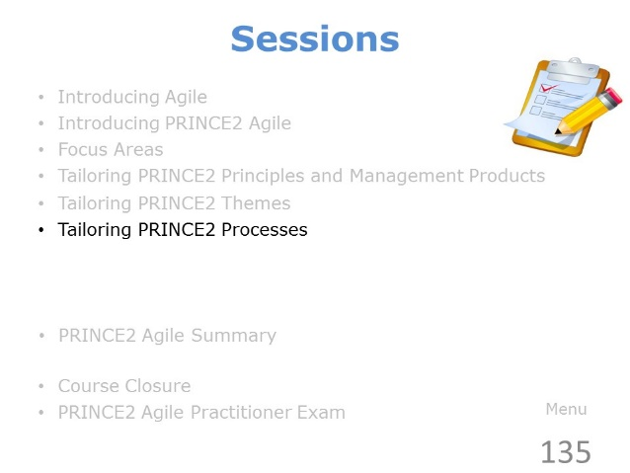 | ………………….………………………….……………………………..  ……………………….……………….…………………………………..  ………………………….……….………………………………………..  ………………….………….……………………………………………..  …………………………………..………………………………………..
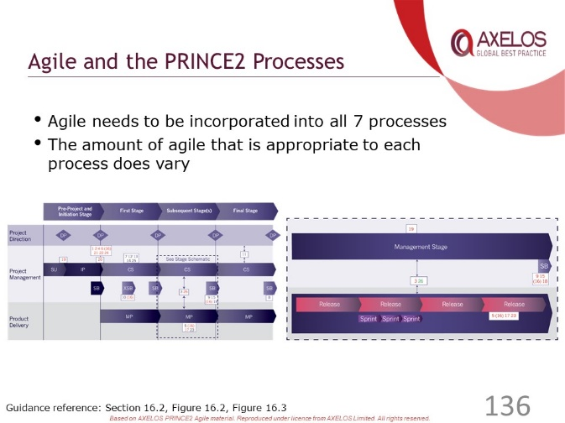 | ………………….………………………….……………………………..  ……………………….……………….…………………………………..  ………………………….……….………………………………………..  ………………….………….……………………………………………..  …………………………………..………………………………………..
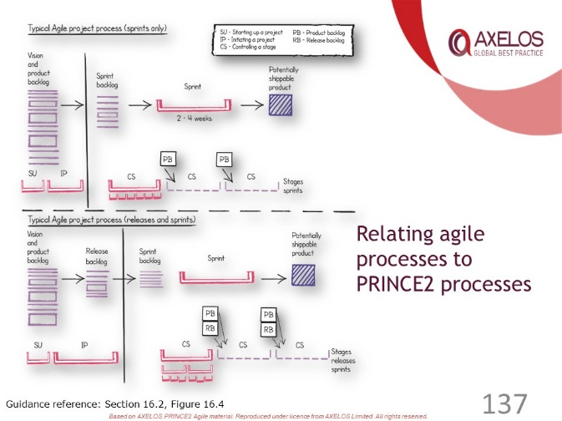 | ………………….………………………….……………………………..  ……………………….……………….…………………………………..  ………………………….……….………………………………………..  ………………….………….……………………………………………..  …………………………………..………………………………………..
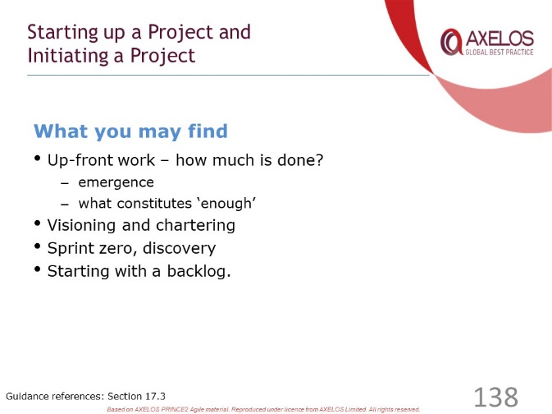 | ………………….………………………….……………………………..  ……………………….……………….…………………………………..  ………………………….……….………………………………………..  ………………….………….……………………………………………..  …………………………………..………………………………………..
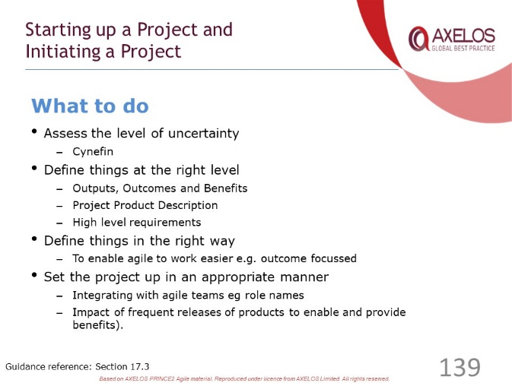 | ………………….………………………….……………………………..  ……………………….……………….…………………………………..  ………………………….……….………………………………………..  ………………….………….……………………………………………..  …………………………………..………………………………………..
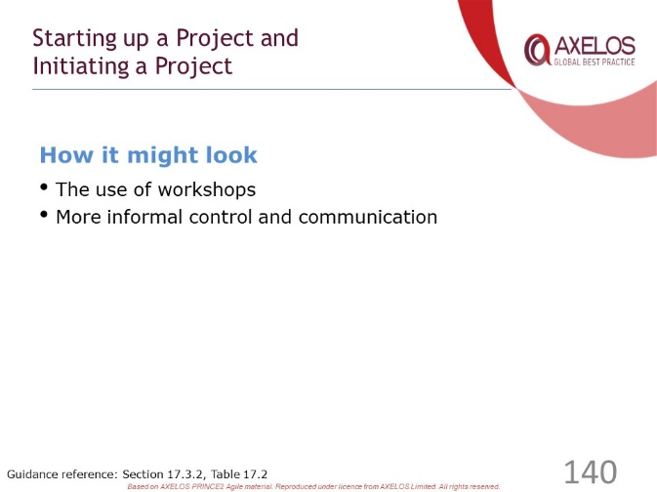 | ………………….………………………….……………………………..  ……………………….……………….…………………………………..  ………………………….……….………………………………………..  ………………….………….……………………………………………..  …………………………………..………………………………………..
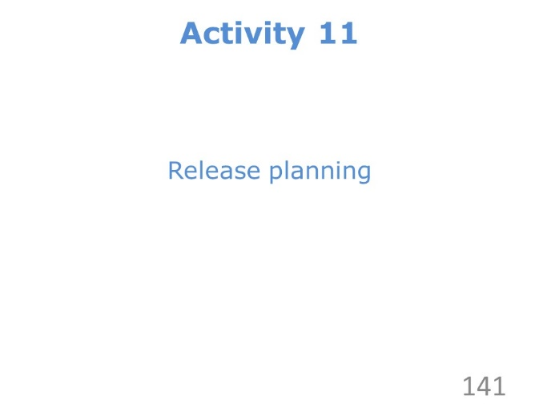 | ………………….………………………….……………………………..  ……………………….……………….…………………………………..  ………………………….……….………………………………………..  ………………….………….……………………………………………..  …………………………………..………………………………………..
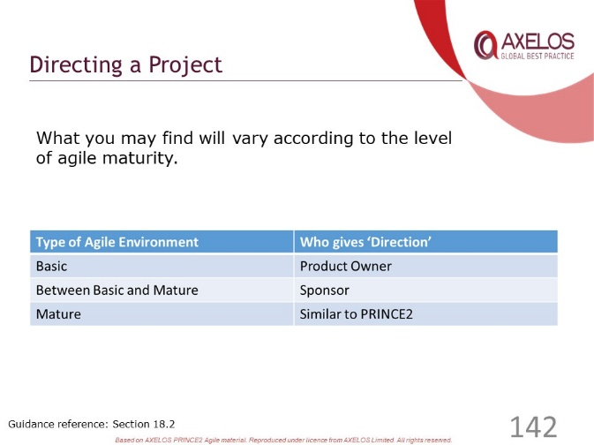 | ………………….………………………….……………………………..  ……………………….……………….…………………………………..  ………………………….……….………………………………………..  ………………….………….……………………………………………..  …………………………………..………………………………………..
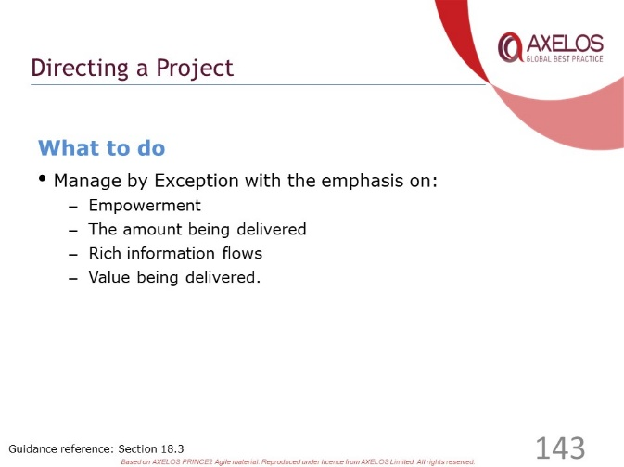 | ………………….………………………….……………………………..  ……………………….……………….…………………………………..  ………………………….……….………………………………………..  ………………….………….……………………………………………..  …………………………………..………………………………………..
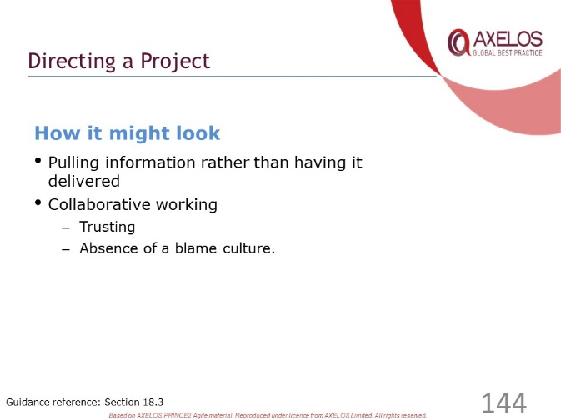 | ………………….………………………….……………………………..  ……………………….……………….…………………………………..  ………………………….……….………………………………………..  ………………….………….……………………………………………..  …………………………………..………………………………………..
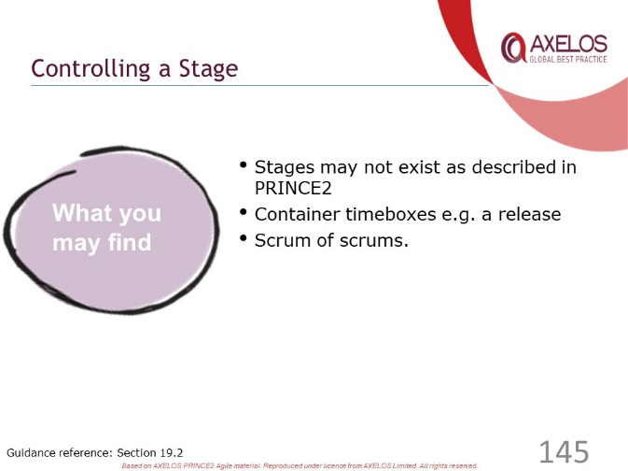 | ………………….………………………….……………………………..  ……………………….……………….…………………………………..  ………………………….……….………………………………………..  ………………….………….……………………………………………..  …………………………………..………………………………………..
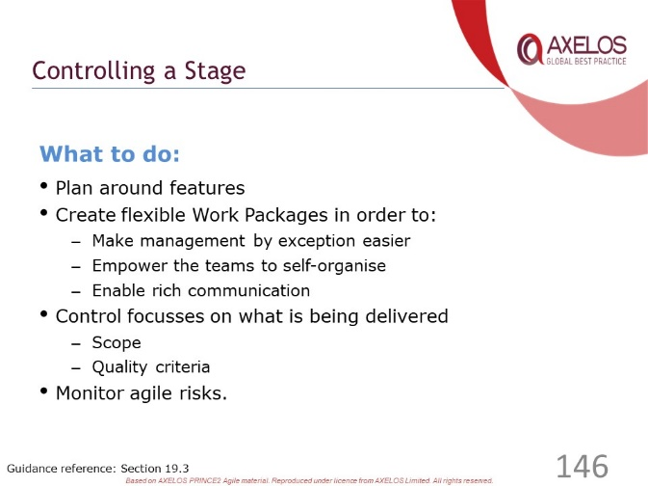 | ………………….………………………….……………………………..  ……………………….……………….…………………………………..  ………………………….……….………………………………………..  ………………….………….……………………………………………..  …………………………………..………………………………………..
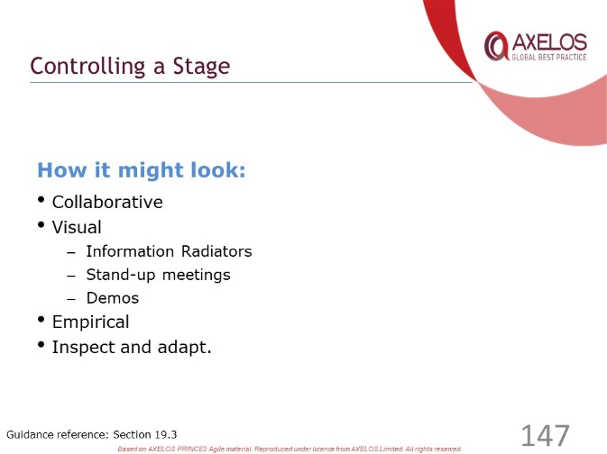 | ………………….………………………….……………………………..  ……………………….……………….…………………………………..  ………………………….……….………………………………………..  ………………….………….……………………………………………..  …………………………………..………………………………………..
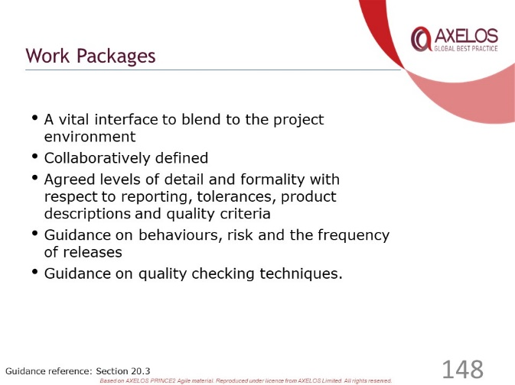 | ………………….………………………….……………………………..  ……………………….……………….…………………………………..  ………………………….……….………………………………………..  ………………….………….……………………………………………..  …………………………………..………………………………………..
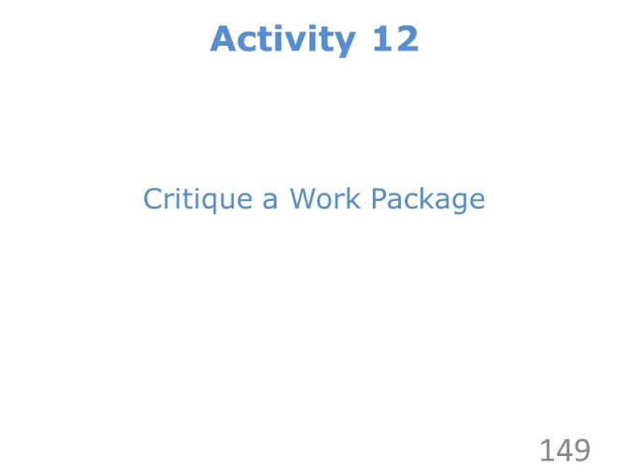 | ………………….………………………….……………………………..  ……………………….……………….…………………………………..  ………………………….……….………………………………………..  ………………….………….……………………………………………..  …………………………………..………………………………………..
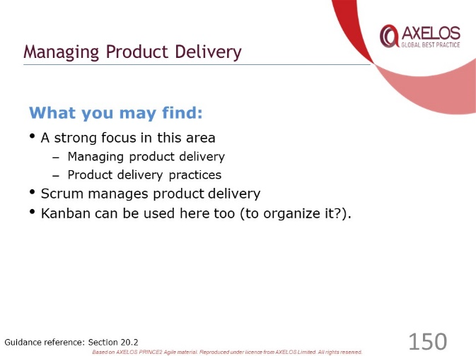 | ………………….………………………….……………………………..  ……………………….……………….…………………………………..  ………………………….……….………………………………………..  ………………….………….……………………………………………..  …………………………………..………………………………………..
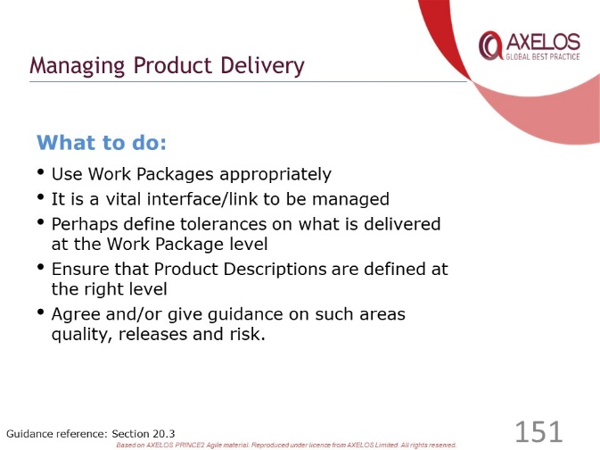 | ………………….………………………….……………………………..  ……………………….……………….…………………………………..  ………………………….……….………………………………………..  ………………….………….……………………………………………..  …………………………………..………………………………………..
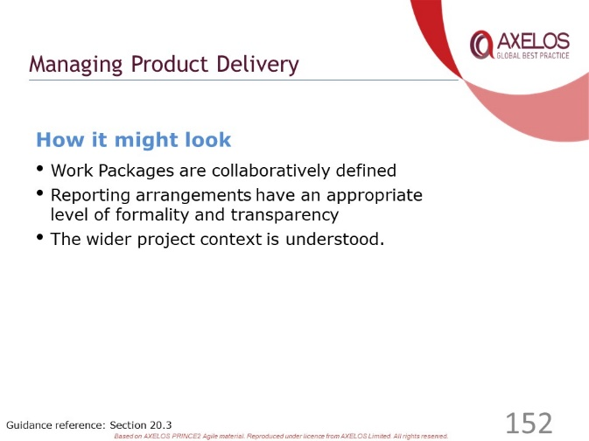 | ………………….………………………….……………………………..  ……………………….……………….…………………………………..  ………………………….……….………………………………………..  ………………….………….……………………………………………..  …………………………………..………………………………………..
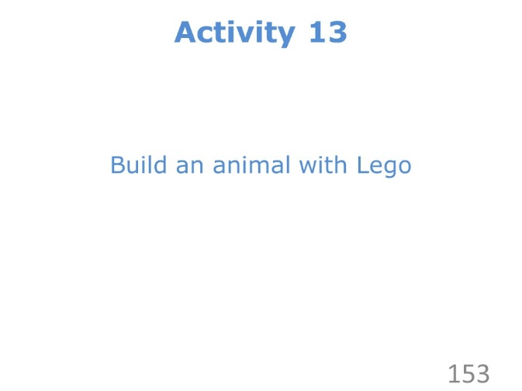 | ………………….………………………….……………………………..  ……………………….……………….…………………………………..  ………………………….……….………………………………………..  ………………….………….……………………………………………..  …………………………………..………………………………………..
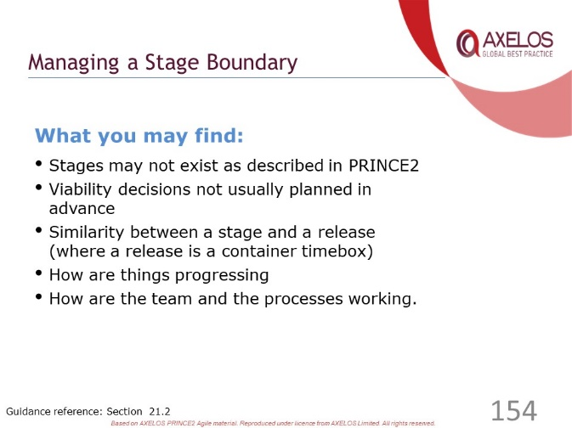 | ………………….………………………….……………………………..  ……………………….……………….…………………………………..  ………………………….……….………………………………………..  ………………….………….……………………………………………..  …………………………………..………………………………………..
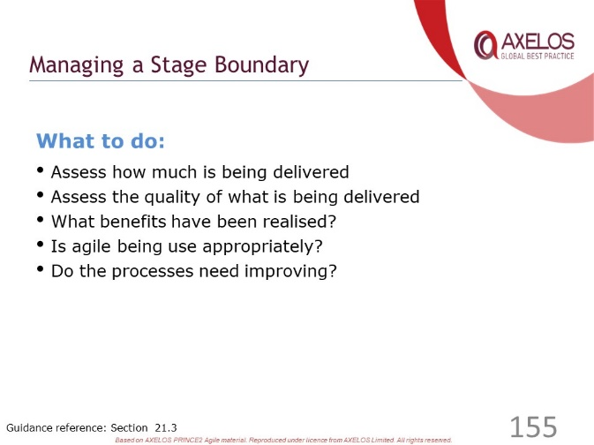 | ………………….………………………….……………………………..  ……………………….……………….…………………………………..  ………………………….……….………………………………………..  ………………….………….……………………………………………..  …………………………………..………………………………………..
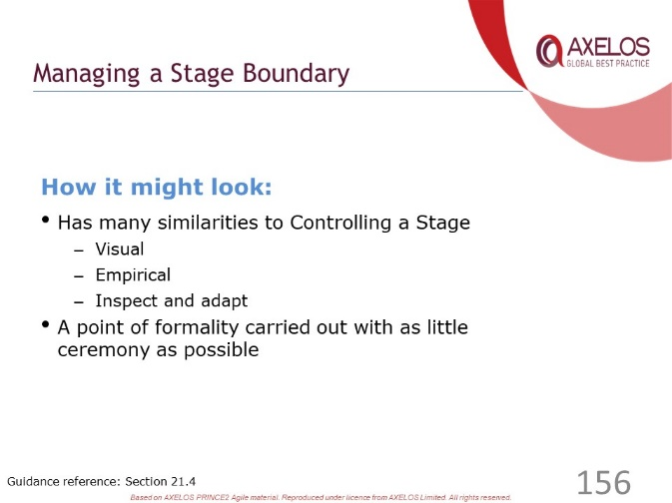 | ………………….………………………….……………………………..  ……………………….……………….…………………………………..  ………………………….……….………………………………………..  ………………….………….……………………………………………..  …………………………………..………………………………………..
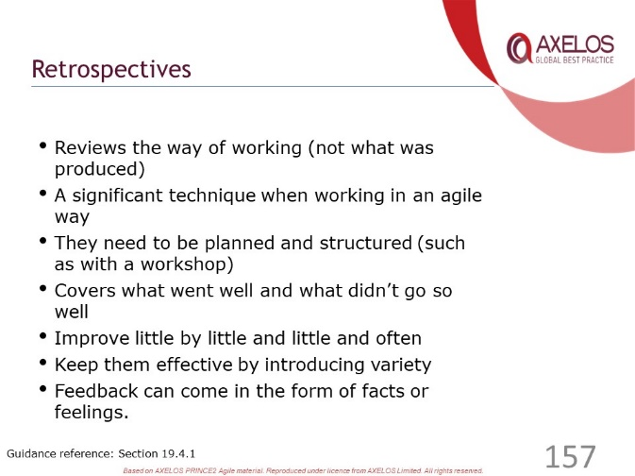 | ………………….………………………….……………………………..  ……………………….……………….…………………………………..  ………………………….……….………………………………………..  ………………….………….……………………………………………..  …………………………………..………………………………………..
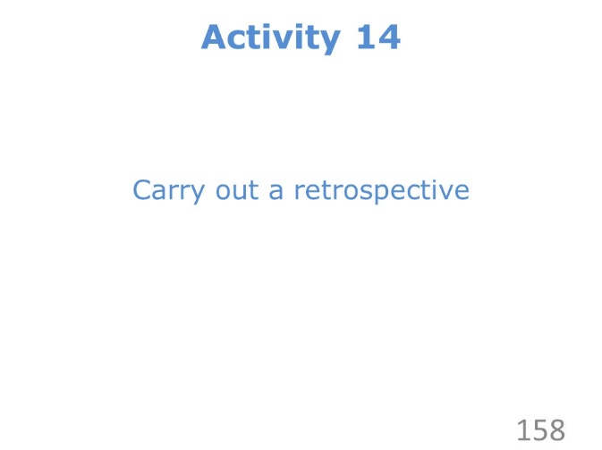 | ………………….………………………….……………………………..  ……………………….……………….…………………………………..  ………………………….……….………………………………………..  ………………….………….……………………………………………..  …………………………………..………………………………………..
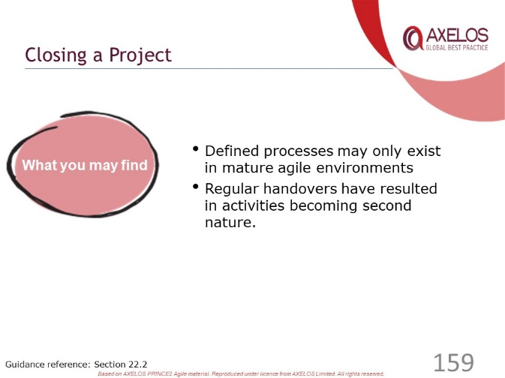 | ………………….………………………….……………………………..  ……………………….……………….…………………………………..  ………………………….……….………………………………………..  ………………….………….……………………………………………..  …………………………………..………………………………………..
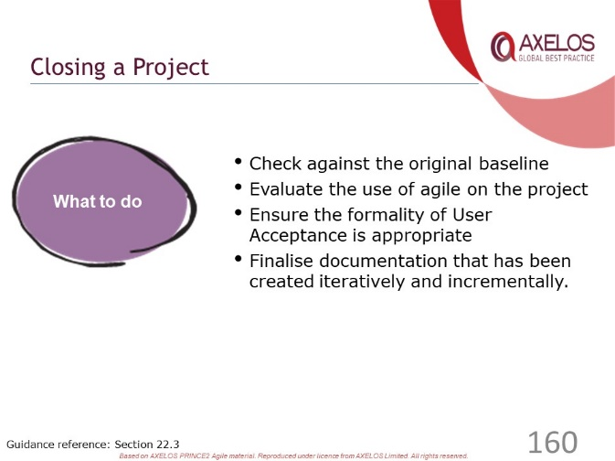 | ………………….………………………….……………………………..  ……………………….……………….…………………………………..  ………………………….……….………………………………………..  ………………….………….……………………………………………..  …………………………………..………………………………………..
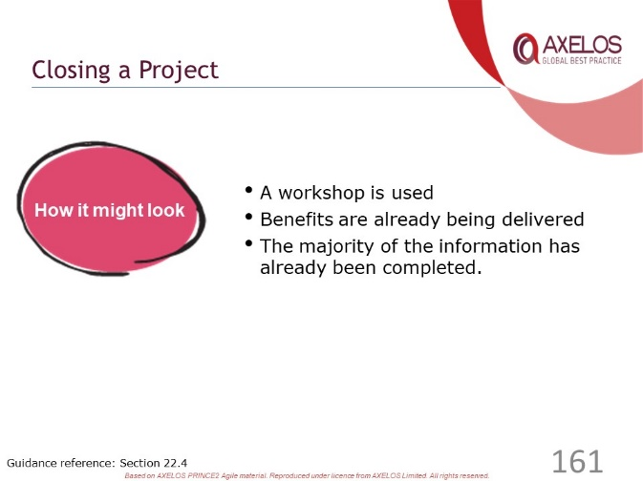 | ………………….………………………….……………………………..  ……………………….……………….…………………………………..  ………………………….……….………………………………………..  ………………….………….……………………………………………..  …………………………………..………………………………………..
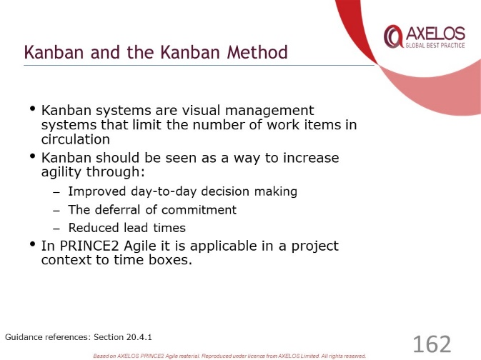 | ………………….………………………….……………………………..  ……………………….……………….…………………………………..  ………………………….……….………………………………………..  ………………….………….……………………………………………..  …………………………………..………………………………………..
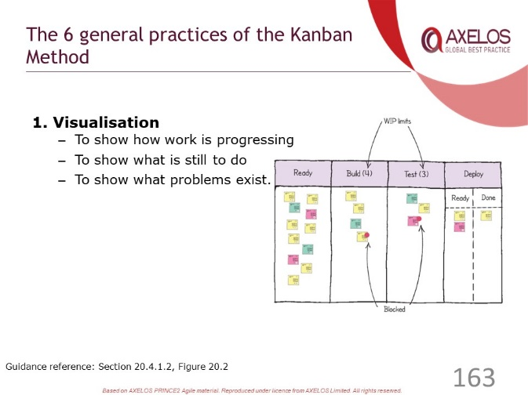 | ………………….………………………….……………………………..  ……………………….……………….…………………………………..  ………………………….……….………………………………………..  ………………….………….……………………………………………..  …………………………………..………………………………………..
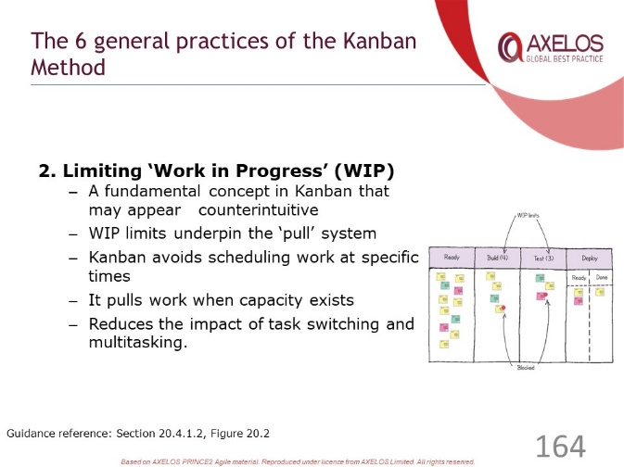 | ………………….………………………….……………………………..  ……………………….……………….…………………………………..  ………………………….……….………………………………………..  ………………….………….……………………………………………..  …………………………………..………………………………………..
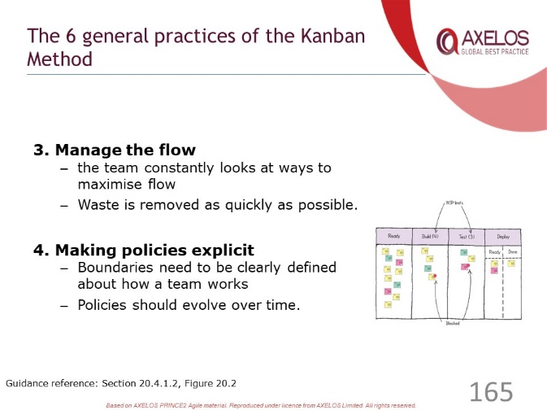 | ………………….………………………….……………………………..  ……………………….……………….…………………………………..  ………………………….……….………………………………………..  ………………….………….……………………………………………..  …………………………………..………………………………………..
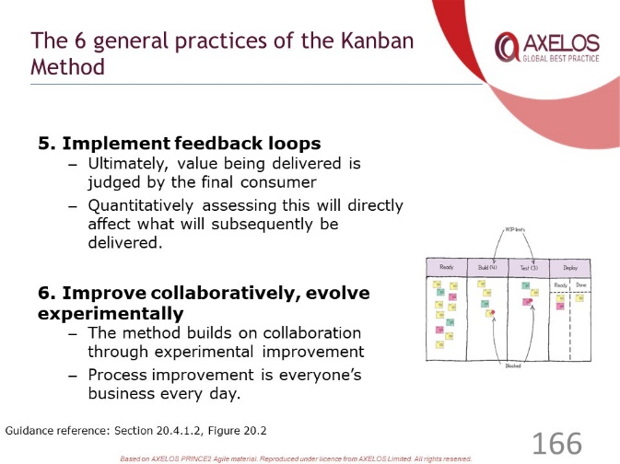 | ………………….………………………….……………………………..  ……………………….……………….…………………………………..  ………………………….……….………………………………………..  ………………….………….……………………………………………..  …………………………………..………………………………………..
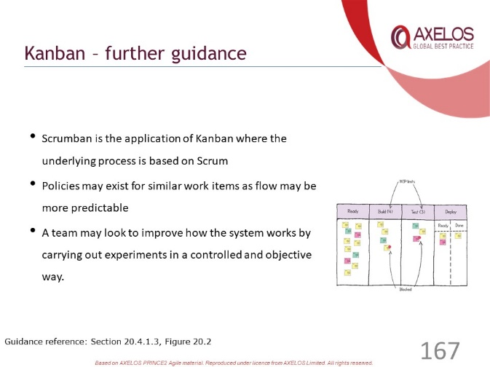 | ………………….………………………….……………………………..  ……………………….……………….…………………………………..  ………………………….……….………………………………………..  ………………….………….……………………………………………..  …………………………………..………………………………………..
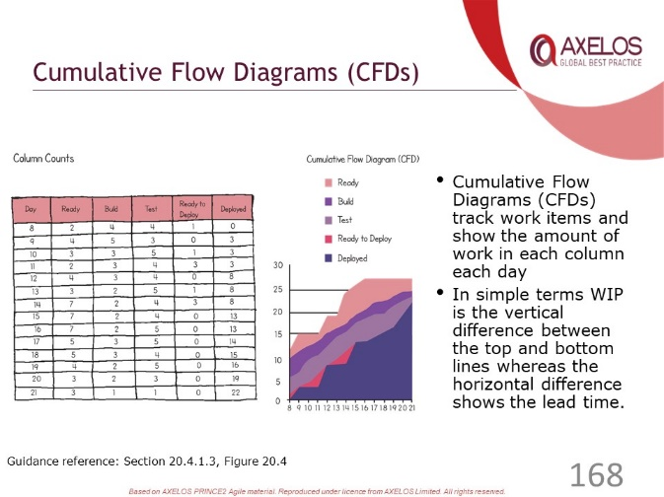 | ………………….………………………….……………………………..  ……………………….……………….…………………………………..  ………………………….……….………………………………………..  ………………….………….……………………………………………..  …………………………………..………………………………………..
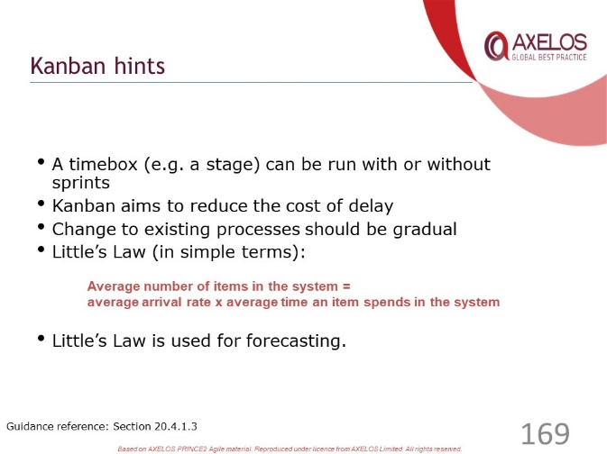 | ………………….………………………….……………………………..  ……………………….……………….…………………………………..  ………………………….……….………………………………………..  ………………….………….……………………………………………..  …………………………………..………………………………………..
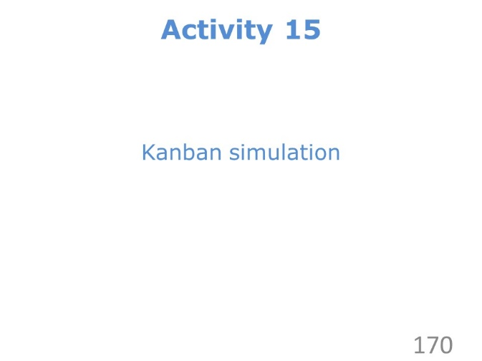 | ………………….………………………….……………………………..  ……………………….……………….…………………………………..  ………………………….……….………………………………………..  ………………….………….……………………………………………..  …………………………………..………………………………………..
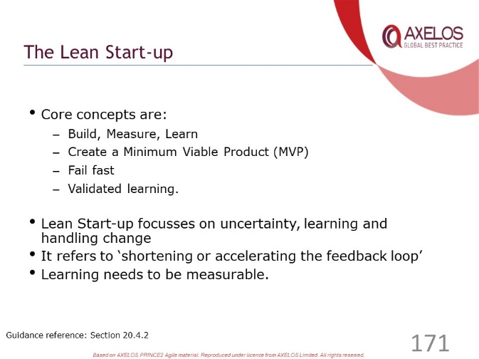 | ………………….………………………….……………………………..  ……………………….……………….…………………………………..  ………………………….……….………………………………………..  ………………….………….……………………………………………..  …………………………………..………………………………………..
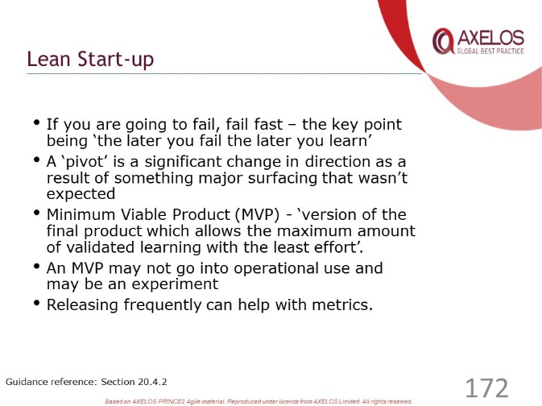 | ………………….………………………….……………………………..  ……………………….……………….…………………………………..  ………………………….……….………………………………………..  ………………….………….……………………………………………..  …………………………………..………………………………………..
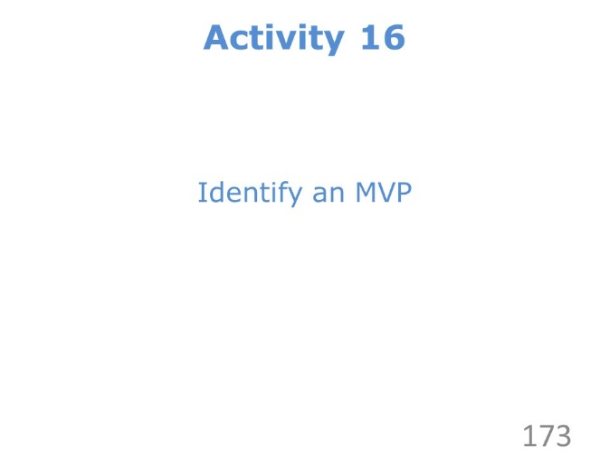 | ………………….………………………….……………………………..  ……………………….……………….…………………………………..  ………………………….……….………………………………………..  ………………….………….……………………………………………..  …………………………………..………………………………………..
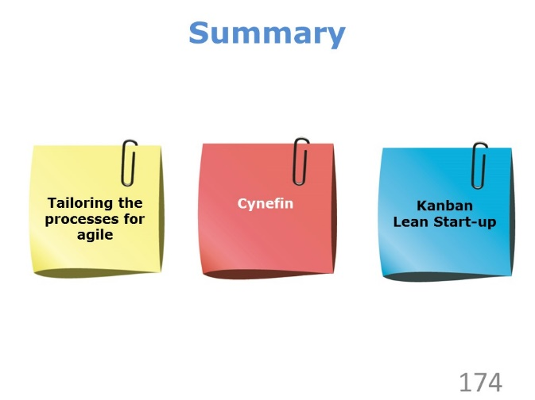 | ………………….………………………….……………………………..  ……………………….……………….…………………………………..  ………………………….……….………………………………………..  ………………….………….……………………………………………..  …………………………………..………………………………………..
………………….………………………….……………………………..

……………………….……………….…………………………………..

………………………….……….………………………………………..

………………….………….……………………………………………..

…………………………………..………………………………………..

Review Questions – Processes

1 | The team has created a plan of 5 one-week timeboxes that always end on a Friday. The Senior User has decided to visit the team every Friday to attend their regular reviews. Which reason BEST explains whether this is a suitable approach for the Directing a Project process?  a) It is a good approach because the Senior User will be able to oversee  the performance of the team  b) It is a good approach because regular reviews will provide rich information  to assess project viability  c) It is a poor approach because the reviews should be scheduled as needed  when products are developed  d) It is a poor approach because the Senior User should focus on looking at  the information radiator instead
2 | The Project Manager is creating the Stage Plan for the next stage. The Project Manager is trying to incorporate several Work Packages into the Stage Plan. How should the Stage Plan be produced?  a) By pulling tasks from the backlog dynamically into the Work Package as  soon as there is capacity  b) Using rationalism to estimate the effort to deliver the sprints during the  stage  c) By the Project Manager after discussing which user stories should be  delivered  d) Using the velocity from the previous stage, working together with the  Scrum Master and team members
3 | The Project Manager has agreed that the daily stand-up room will have an issues register on the wall for project issues, and all teams will display their own issue register on their team wall as well. Which of the following BEST explains whether this approach is suitable?  a) The teams will be able to physically update their issues during their  daily stand-ups  b) A spreadsheet that all teams can access would be a more agile way  of working  c) The issue registers may be difficult to keep synchronised across the teams  d) An informal approach encourages issues to be raised that might  otherwise be missed
4 | The team have noted in their daily stand-up that they cannot work out the versions and review status of the component elements of several of the products of the timebox. Which core practice of Kanban might be MOST useful to immediately help with the Managing Product Delivery process?  a) Identify the effect of delaying the delivery of a product in a daily stand-up  b) Refer to a Cumulative Flow Diagram to identify the status of the  remaining work  c) Visualise the status of work using a ‘ticket’ board with swim lanes  d) Carry out a safe-to-fail experiment to identify a better way of working
5 | During a recent retrospective, many team members expressed frustration that some members of the team had worked only on specific products and had not helped in the delivery of others. Therefore, the team produced a Glad! Sad! Mad! board. Which of the following statements explains why this approach to identifying issues is appropriate for the Controlling a Stage process  a) The retrospective empowers the delivery teams to work with a visual  approach during a timebox  b) A retrospective should identify all areas for improvement that should  be actioned by the team  c) Glad! Sad! Mad! is feedback technique that focusses on feelings and  helps to identify improvements  d) Glad! Sad! Mad! is a feedback technique used in a retrospective to  monitor the progress of a team

Check your answers with those on page 81.

PRINCE2 Agile Summary

Slides
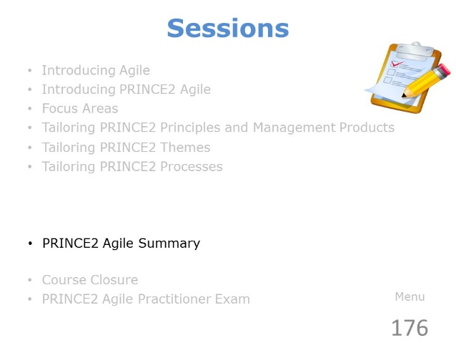 | ………………….………………………….……………………………..  ……………………….……………….…………………………………..  ………………………….……….………………………………………..  ………………….………….……………………………………………..  …………………………………..………………………………………..
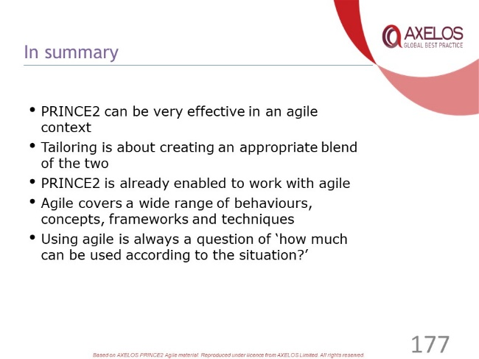 | ………………….………………………….……………………………..  ……………………….……………….…………………………………..  ………………………….……….………………………………………..  ………………….………….……………………………………………..  …………………………………..………………………………………..

Review Questions – Summary

1 | A project has been set up with multiple teams, one for each workstream. Each team has its own Team Manager. A specialist with knowledge required by all workstreams has been appointed to act as Customer Representative in all four teams. Which of the following BEST explains how this approach tailors the Organisation them?  a) It tailors the theme poorly because each team should have dedicated  resources and a stable team  b) It tailors the theme poorly because a Customer SME should provide  expert knowledge to the teams  c) It tailors the theme well because the Customer Representative  provides specialist information to the teams  d) It tailors the theme well because the Customer Representative should  work full time on the project
2 | There are several Work packages being delivered during a stage. The Scrum Master in one team is concerned that project-level issues may be overlooked and this might impact her team during the current timebox. Which agile way of working can be used as part of the Controlling a Stage process to ensure that these issues are identified?  a) MoSCoW  b) Scrum of Scrums  c) Retrospectives  d) User stories
3 | The Project Manager has agreed with the Team Manager of a team delivering a Work Package that the team should try using the Kanban method along with their existing ways of working. The team is going to display a Kanban board as part of their information radiator. Which of the following explains why these approaches can be combined effectively during the Managing Product Delivery process?  a) A Kanban board makes the status of their Work Package visible to the  whole team  b) Using Kanban, the amount of work being carried out by a team is  limited, improving delivery during each sprint  c) Kanban aims to deliver as much of the Work Package as quickly as possible  d) Kanban enables collaborative working between team members  delivering the Work Package.
4 | During a timebox, there was a request from operational management that the Customer SME be allowed to return to operational work to resolve an urgent problem. This request was successfully resisted by the Executive. At the subsequent retrospective, the following observation was made: “The stability of the team during the sprint contributed to delivery of all Must Haves and 4 out of 5 Should Haves”. Where should this observation be captured?  a) In the risk register reflecting the level of risk associated with team instability  b) In the lessons log displayed on the team information radiator  c) In the highlight report produced along with a burn-up chart  d) In the daily log by the Project Manager following the retrospective
5 | The Project Manager used the Agilometer to assess the prevailing agile environment and, consequently, took action to improve the low score achieved on the Flexibility on what is delivered slider. When should the Project Manager undertake a further assessment in order to determine if further action is required to increase the slider score?  a) Sprint review  b) Sprint retrospective  c) Release retrospective  d) Project retrospective

Check your answers with those on page 81.

Course Closure

Slides
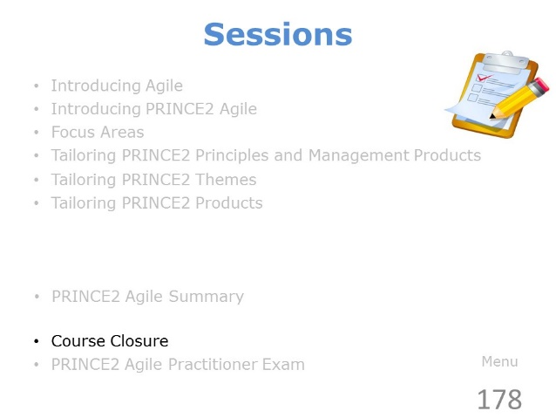 | ………………….………………………….……………………………..  ……………………….……………….…………………………………..  ………………………….……….………………………………………..  ………………….………….……………………………………………..  …………………………………..………………………………………..
………………….………………………….……………………………..

……………………….……………….…………………………………..

………………………….……….………………………………………..

………………….………….……………………………………………..

…………………………………..………………………………………..
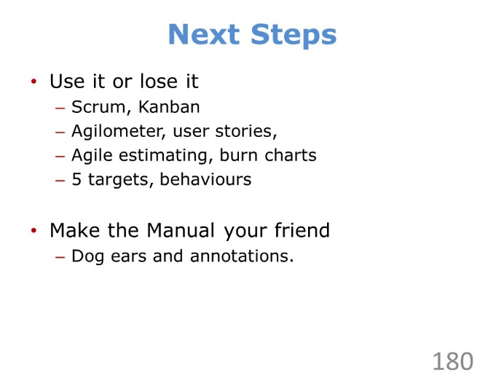 | ………………….………………………….……………………………..  ……………………….……………….…………………………………..  ………………………….……….………………………………………..  ………………….………….……………………………………………..  …………………………………..………………………………………..
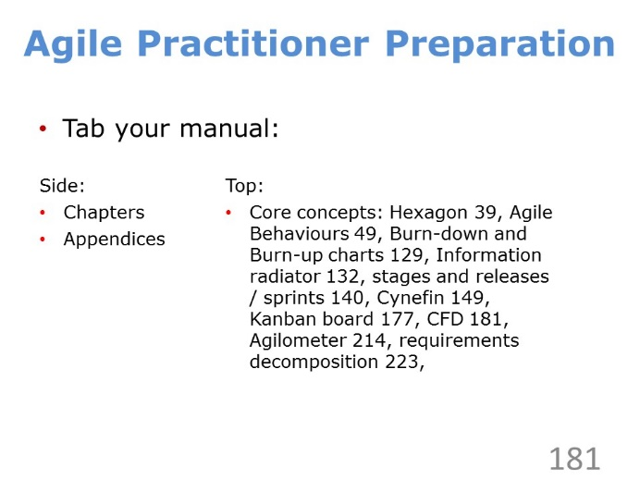 | ………………….………………………….……………………………..  ……………………….……………….…………………………………..  ………………………….……….………………………………………..  ………………….………….……………………………………………..  …………………………………..………………………………………..
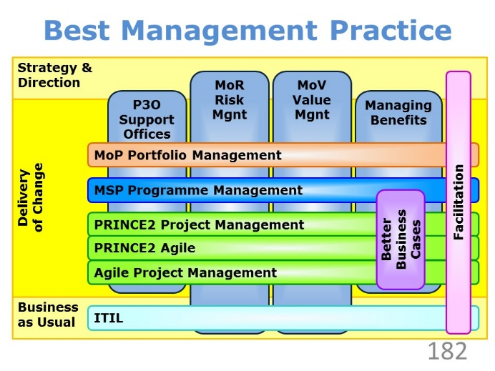 | ………………….………………………….……………………………..  ……………………….……………….…………………………………..  ………………………….……….………………………………………..  ………………….………….……………………………………………..  …………………………………..………………………………………..
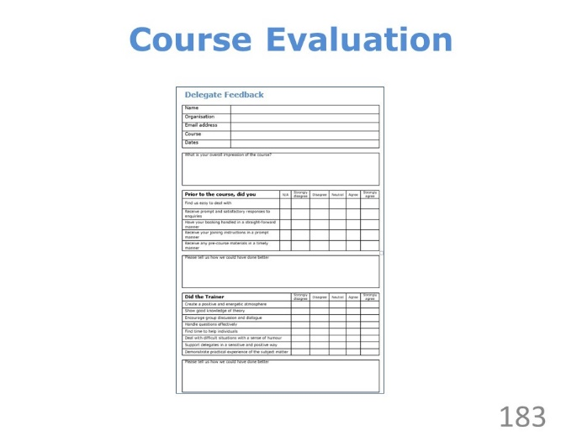 | ………………….………………………….……………………………..  ……………………….……………….…………………………………..  ………………………….……….………………………………………..  ………………….………….……………………………………………..  …………………………………..………………………………………..

The PRINCE2 Agile Practitioner Exam

Slides
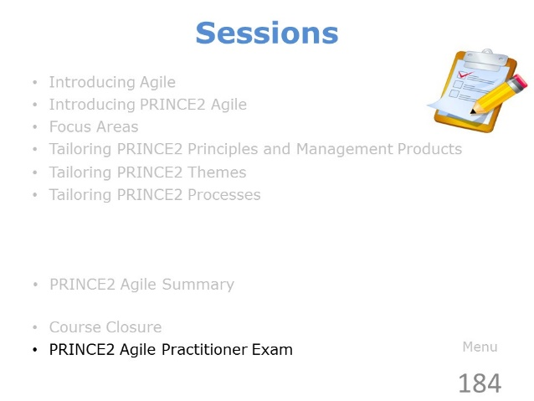 | ………………….………………………….……………………………..  ……………………….……………….…………………………………..  ………………………….……….………………………………………..  ………………….………….……………………………………………..  …………………………………..………………………………………..
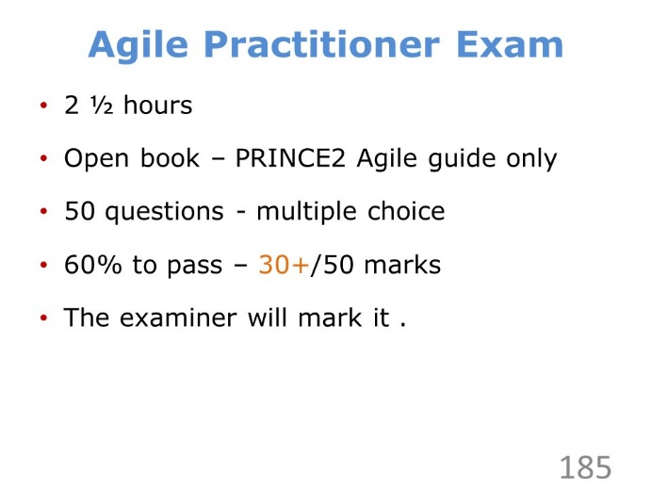 | ………………….………………………….……………………………..  ……………………….……………….…………………………………..  ………………………….……….………………………………………..  ………………….………….……………………………………………..  …………………………………..………………………………………..
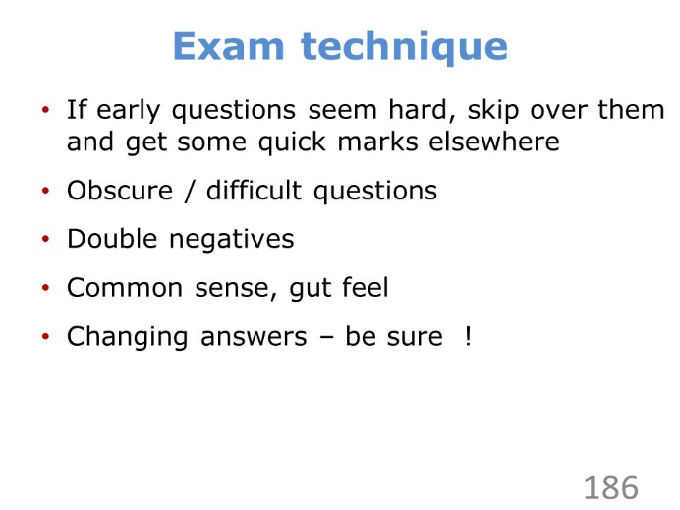 | ………………….………………………….……………………………..  ……………………….……………….…………………………………..  ………………………….……….………………………………………..  ………………….………….……………………………………………..  …………………………………..………………………………………..
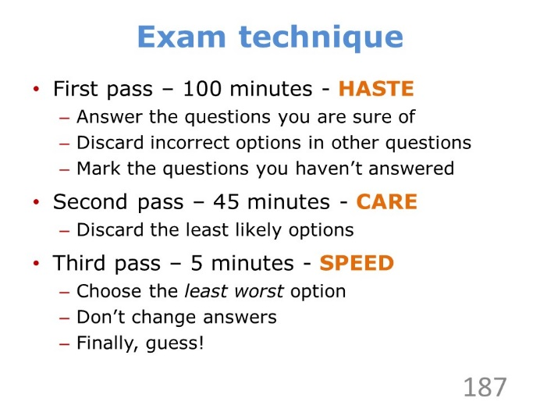 | ………………….………………………….……………………………..  ……………………….……………….…………………………………..  ………………………….……….………………………………………..  ………………….………….……………………………………………..  …………………………………..………………………………………..

Tips
- Feel free to write on the scenario and question booklets; but remember, nothing you write in these booklets will be marked.
- Underline keywords and qualifiers such as not, true, false, correct and incorrect, to help you understand clearly what the question is asking you.
- When you’ve answered a question, mark it as done in the question booklet.
- In your first pass through the paper, if you find a difficult question, try to eliminate any obviously wrong answers, then tag the question and move on. Come back to the question in your second or third pass.
- Attempt every question. By the time you find yourself guessing, more likely than not you’ve already done enough to pass the exam.
- Make your answer obvious – make sure there is no ambiguity or doubt about what is your answer.
- Be careful of double negatives such as ‘is not false’; perhaps replace such phrases in the question with the equivalent positive expression such as ‘is true’.

Preparation
- Go over the answers and rationale to the Sample Exam.
- Go over the answers to the Activities.
- Read as much of the PRINCE2 Agile manual as possible.
- Get a good night’s sleep.
- Keep the exam in perspective; the pass rate is high and the pass mark is only 60%.

Results and Certificates
The Examination Institute will mark the PRINCE2 Agile Practitioner exam after the course has completed and will release the confirmed result soon after.
For successful examination candidates, the Examination Institute will make your Certificate available to you via their candidate portal.

Case Study and Activities

Chestertons Cheese
The Chesterton family are dairy farmers. They have successfully diversified into the making and selling of a wide range of cheeses.
Chestertons sell most of their cheese to national supermarkets (referred to as ‘trade customers’). However, two years ago they decided to sell cheese directly to the public by receiving orders by telephone or over the counter at the farm shop. They did this in order to open up a new market in case their trade customers became less profitable.
They employ several staff who help with the running of the machinery, customer service and distribution. Deliveries to the public are done by courier. Trade deliveries are carried out using the 6 company vans.
They are currently receiving an increasing number of phone orders from the public for cheese every day and they have now reached a point where they are looking at selling cheese ‘online’.
The Chestertons currently have a website but it is very old and only has pictures of the farm, basic details about their cheeses, and contact details. It will need to be completely replaced.
The Chestertons are looking for a website which will shift most of the phone traffic and visits to the farm shop onto the web.
From the research they have done so far it looks likely that they could possibly increase cheese sales to the public without recruiting more staff. The cost of the website looks like being $20,000 to build with a service contract of $400 per month. Initial estimates suggest that increased sales could pay for this within 12 months.

Activity 1 – What is the level of complexity?
According to the 5 domains in the Cynefin framework, how would you assess the level of complexity involved in the Chesterton’s website project?

Activity 2 – Assess the projects with the Agilometer
Using the 6 sliders on the Agilometer, how would you assess the Chesterton’s website project or the workstreams in the practice exam paper?

Activity 3 – Write some requirements
Write down 2 or 3 requirements for the new website. For example, what would you want the website to do or how you would like it to perform.
Write one of the functional requirements in the User Story format.

Activity 4 – MoSCoW prioritisation
Examine the ‘requirements list’ provided below. Decide on your ‘MoSCoW’ for each one.
No. | Requirements for the new website | M/  S/  C | Estimate  (days)
1 | Create an order for some cheese |  | 4
2 | Change an existing open order that has been submitted |  | 3
3 | Create a customer account/login |  | 3
4 | Choose to have the order gift wrapped |  | 1
5 | Browse product information (e.g. ingredients) |  | 2
6 | Show a price list/catalogue of cheeses |  | 5
7 | Ensure that payment over the web is secure |  | 3
8 | Search and filter by size, price and type of cheese |  | 2
9 | Enable a visitor to sign up to receive a newsletter |  | 2
10 | Provide a feedback facility for Chestertons |  | 1
11 | Promote special offers |  | 2
12 | Enter a separate invoice address |  | 2
13 | Enter an alternative delivery address |  | 2
14 | Provide information about Chestertons (‘about us’) |  | 1
15 | Allow payment by credit card/debit card |  | 6
16 | Automatically authorise credit card payment |  | 3
17 | Support other payment methods (e.g. PayPal) |  | 2
18 | Notify the customer that the order has been dispatched |  | 2
19 | Create, view and amend customer details |  | 5
20 | Provide an area for trade customers only |  | 4
21 | Support discounts related to size of order |  | 2
22 | Offer choice of delivery times |  | 3

Activity 5 – Preparing for a workshop
Before a workshop takes place there are a handful of steps which should take place in order to run the workshop in the most effective way. What do you think they are?

Activity 6 – Ordering the behaviours
Examine the 5 behaviours in PRINCE2 Agile.
Rank them in order of importance (from 1st to 5th), in your opinion.

Activity 7 – Assigning customer roles
Assuming that you are the Project Manager/Team Manager for the website project, who would you want to assign to the following roles in order to get the most appropriate view of the customer?
- Executive
- Senior User
- Customer Subject Matter Expert
- Customer Representative
You can assign more than one person to a role if you wish. Explain each assignment.
Use the following ‘people profiles’:
Mrs. Chesterton
Strong accountancy skills. Authorised all of the new initiatives. Very decisive. Doesn’t like the impersonal nature of the internet. Will only eat organic cheese.
Mr. Chesterton
Likes to play around with ideas. Starts many things off but rarely finishes anything. Decides where the family business should be going at a strategic level. Very keen on technology and gadgets. Wears a watch that tells him how high he is above sea-level but no one is sure why.
Jake Chesterton
‘Hands-on’ day to day running of the cheese business. Leads a small team that handles all sales calls. Is very operationally focussed on getting the right thing to the right customer. Takes many of the calls. Very reactive – fire-fights problems as they happen. Likes to go for long walks on his own.
Kerry Chesterton
Leads the Customer Service and Marketing department. Generally keeps everyone happy. Responsible for dealing with any queries including those about new types of cheese. Responsible for the ‘image’ of Chestertons Cheese. Cares passionately about the environment.
Mirek Kowalski
The I.T. Manager who started as a website designer at Chestertons three years ago. Knows all of the existing systems and applications in a lot of detail, works long hours and leaves his phone on all the time in case of problems. Likes to straighten the pictures that hang in the reception area.
Mimi Bertillon
Leads a small team that handles order fulfilment. Is involved in the vital part of the process where the orders are packed and addressed according to the picking note information provided by Jake’s team. Is allergic to cheese.
Sanjay Patel
Responsible for looking after the delivery side of the business. This includes receiving raw materials and the dispatch of packaged orders. Very good inter-personal skills. Really loves cheese.
Sam O’Farrell
Has a lot of experience of many areas of the company. Has worked for the Chestertons for many years and is seen as the ‘old hand’. Is currently looking after the production lines, ensuring that they run as well as possible. Affectionately known as ‘Grumpy’. Believes cheese is only cheese if it is hard.

Activity 8 – Group estimation
Suppose you had a child’s puzzle/jigsaw like this.
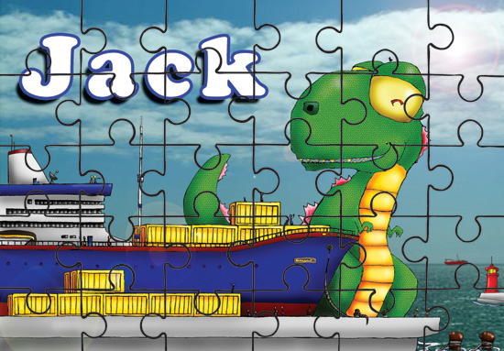
Each member of the group should estimate how long it would take them to complete such a puzzle, and write down their estimate without showing anyone else.
Then write up each delegate’s estimate – normally the difference is quite large.
Ask the group what they would do with all of these estimates.

Activity 9 – Burn up and burn down charts
The following diagram shows a burn down and burn up chart for the same sprint. What do you think happened over the course of the sprint?
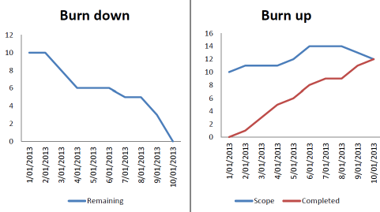

Activity 10 – Creating quality criteria
Each team is to create the Quality Criteria (which will be part of a Product Description) for a quarter page advertisement in a local newspaper as part of Chestertons new marketing campaign (in the practice exam paper).
Develop the Quality Criteria in the form of user-focused questions (see the top of page 230 in the PRINCE2 Agile manual).
When instructed, develop an advertisement that satisfies the quality criteria.

Activity 11 – Release planning
Using the MoSCoWed requirements from Activity 4, create a release plan covering 60 days for the project. How many releases will you need? Generally speaking what is the objective of each release and will each put something into operational use?

Activity 12 – Critiquing a Work Package
Critique the following Work Package.

Activity 13 – Building an animal from Lego
This is a competition to create an animal from Lego bricks. The winning team will be the team that delivers the highest score at the end of the game. Use the Scrum technique.
General Guidance
You do not have to deliver everything.
You cannot make anything between sprints.
If you build an enclosure then all of the bricks must be joined together.
The ‘moving part’ must move at least 1cm.
AC/QC = Acceptance Criteria/Quality Criteria
Legs
No. | 0113
What | The animal must have 4 legs
Why | So that it can walk a long way for food
Value | 40
AC/QC | None of the 4 legs touch each other and they are all the same size

Feet
No. | 0221
What | The animal should have 4 feet
Why | So that it can run to avoid predators
Value | 20
AC/QC | There is a foot on the end each leg and the foot sticks out

Eyes
No. | 0311
What | The animal should have 2 eyes
Why | So that it can see and estimate distance
Value | 40
AC/QC | The eyes are the same colour and not touching each other

Hair
No. | 0432
What | The animal’s head should have hair on it
Why | So that it can avoid getting sunburnt
Value | 10
AC/QC | The hair is a different colour to the head

Nose
No. | 0511
What | The animal must have a nose
Why | So that it can smell things to eat and predators to fear
Value | 20
AC/QC | The nose sticks out from the head

Tail
No. | 0611
What | The animal should have a tail
Why | So that it can communicate to other animals
Value | 20
AC/QC | The tail sticks out from the body

Head
No. | 0712
What | The animal must have a head
Why | So that it can perform basic life support functions such as thinking and eating
Value | 50
AC/QC | The head is not touching the body and is the highest part of the animal

Body
No. | 0813
What | The animal must have a body
Why | So that it contains vital organs like the lungs and stomach
Value | 40
AC/QC | The body is longer and wider then its depth

Ears
No. | 0912
What | The animal should have ears
Why | So that it can hear predators
Value | 30
AC/QC | The ears are not the same colour as the eyes and they stick out from the head

Moving Part
No. | 1031
What | The animal should have a moveable part
Why | So that it can attract other animals
Value | 30
AC/QC | The part can move without needing to change the animal in any way

Stands Up
No. | 1111
What | The animal should stand up on its own
Why | So that it has less chance of getting attacked
Value | 10
AC/QC | It does not fall over when light pressure is applied to it

Neck
No. | 1422
What | The animal should have a long neck
Why | So that it can eat food from high trees
Value | 30
AC/QC | The neck is longer than the legs

Tree
No. | 1333
What | The enclosure should have a tree in it
Why | So that it can provide shade for the animal
Value | 40
AC/QC | The tree should have three branches and be taller than the body of the animal

Black and Yellow
No. | 1543
What | The animal should not have any black bricks touching any yellow bricks
Why | So that the animal doesn’t die
Value | 20
AC/QC | There are no black bricks touching any yellow bricks

More Legs
No. | 1642
What | The animal should have 6 legs
Why | So that it can run very fast to get water when water is scarce
Value | 20
AC/QC | None of the 6 legs touch each other and 4 of them are all the same size

Enclosure
No. | 1234
What | The animal should live in an enclosure
Why | So that it is safe from predators
Value | 50
AC/QC | The animal must be fully contained within the enclosure when viewed from above. The enclosure is one structure.

Activity 14 – Carrying out a retrospective
Carry out a Retrospective on the last (or any) activity. What went well and what didn’t go so well? What would you do differently next time?

Activity 15 – Kanban simulation
Summary:
This Agile game is based on The Penny Game.
Each round after the first is essentially optional, you can choose exactly which lessons you wish to deliver. This may be all of them for more experienced teams, or fewer for those new to Agile.
Timing: 20 – 60 minutes depending on team size and number of rounds.
Materials:
- 20 x 10 cent coins
- 10 x 50 cent coins
- Whiteboard / Blackboard / Flipchart
- 1 x stopwatch per team
- Post-Its
- Pens for Post-Its and board
Instructions:
This game will be run over several rounds, with each round introducing a new concept.

Setup:
- Split your group into equal teams of at least 4, ideally not more than 6.
- Choose one person from each team to be the timer.
- If there are people left after this split, they can take charge of recording the results.
- Each team should form a line, sitting down along the edge of some work surface, like a table length.
- Ensure the timer for each team has a stopwatch.
- Give each team an equal amount of coins (around 8 – 15 is good).
- You should now have equal teams with an identical set of coins in front of the first person in each team, as below.
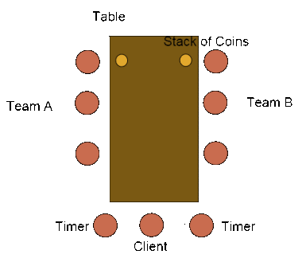
- Use the following grid to hold your team’s scores for the completed rounds.

 | Team A
Round | First | Last
1
2
3
4
5

Round 1 – Batch Size:
Explain to the group that they each form a different team. Each team will complete the same work, which in this case is the flipping of coins. Each team member will need to complete the work in batches, before passing the batch to the next person. People are only allowed to use 1 hand, and the batch must be stacked in a tower before they can pass it to the next person.
Give each person a job title to model a real project. Commonly, this would be some subset of ‘Analyst’, ‘Designer’, ‘Programmer’, ‘Tester’ and perhaps something like ‘Acceptance’ if needed.
Tell the teams that you are the client, and that when the batch reaches you, they have delivered that value. Tell each timer that they must record the time it took for the first and last batches to be processed.
Finally, tell each team that they will be working with a different batch size. For 2 teams, use a full batch (the amount of coins each team has) and 1 for the sizes. This will result in 1 team processing coins individually before passing them, and another processing the whole batch at each station. With more teams, use intermediate numbers; so for 3 you would use 1, 5 and 10 perhaps.
- Get each team to stack their coins in the required batch sizes. Teams working on a single coin can simply use a heap.
- Start the teams working with a countdown.
- Ensure players only use 1 hand and that the work is completed according to their batch size.
- Ensure the time taken for the first and last coins for each team is recorded.
- Stop timers when all work is completed.
- Record scores in the appropriate sections of your grid.
- Asks teams to discuss what they noticed.
Round 2 – Reactive to Change:
Tell everyone that you will be doing the same game, but with some additional coins. The timers will complete the same role as they previously did. All other aspects of the game will be the same.
- Evenly distribute the other coins through the batched stacks of the teams.
- Start the teams working with a countdown.
- Around halfway through, announce that you have changed your mind and now only want the 10 cent pieces.
- Allow the game to finish and record the scores.
- Ask the teams to discuss how the exercise went.
Round 3 – Quick Feedback:
The teams will now continue to use all of the coins, but change requests will no longer play a part.
- Give each ‘Tester’ (or simply choose one of the latter work centres in the chain) in your team a note that says the following: “We need all coins to be face down, reject entire batch back to Developer. You can say why.”. It is vital that this secret message is not shared with other teams or anyone else on their team until the first defective batch has reached them. The aim is for the ‘Tester’ of each team to reject the first faulty batch, explain to the rest of the team why it was rejected, have it ‘reworked’, and then successfully complete the remaining batches.
- Allow the game to finish as normal.
- Ask the teams what they noticed.
Round 4 – Bottlenecks:
This time we will model bottlenecks, and show the difference between local and systemic optimisation. Ask each team to identify their primary bottleneck. They should identify the first work centre as it is this person who delays the next from starting. You may see people identifying themselves because they are slow, steer the conversation towards a more general view.
Next, ask the team how they would optimise that bottleneck. You will generally see people saying that they would use more people. Use this and say you are going to simulate that by allowing that person to use two hands for the next round.
- Tell the first person in each chain that they can now use 2 hands to process their batches. Each batch passed to the next person MUST be stacked on top of the coins that person is waiting to process.
- Start the countdown to begin the game.
- Allow the game to complete and record the scores.
- Ask the teams what they noticed.
Round 5 – Optional:
You may additionally run the game with a further optimisation on the first player here, just to highlight the point of local vs. systemic optimisation.
Alternatively you could choose to allow all teams to optimise their bottlenecks by using 2 hands for every work centre. This would allow the teams to finish with their best output.

Activity 16 – Identifying an MVP
What constitutes an MVP? What would be the MVP for the Chesterton’s project?

Answers to Review Questions

Q | A | Page |  | Q | A | Page
Introducing Agile |  |  |  | Tailoring Themes
1 | A | 13 |  | 1 | C | 130
2 | A | 12 |  | 2 | B | 42
3 | D | 313-322 |  | 3 | D | 85
4 | C | 13 |  | 4 | D | 113
5 | C | 5 |  | 5 | D | 280
Introducing PRINCE2 Agile |  |  |  | Tailoring Processes
1 | D | 41 |  | 1 | B | 156
2 | B | 22 |  | 2 | D | 105
3 | D | 42 |  | 3 | A | 163
4 | A | 149 |  | 4 | C | 177
5 | B | 40 |  | 5 | C | 168
Focus Areas |  |  |  | PRINCE2 Agile Summary
1 | D | 214 |  | 1 | C | 281
2 | C | 221 |  | 2 | B | 162
3 | D | 243 |  | 3 | B | 178
4 | D | 239 |  | 4 | B | 207
5 | A | 249 |  | 5 | C | 216
Tailoring Principles and Products
1 | D | 51
2 | B | 50
3 | A | 205
4 | C | 51
5 | C | 208

Page numbers are based on the 2015 edition of the PRINCE2 Agile manual.

Answers to Activities

Activity 1 – What is the level of complexity?
Generally a website like this would be reasonably straightforward although it wouldn’t be ‘obvious’ – it wouldn’t be ‘complex’ either. Perhaps compare website project to work that is ‘obvious’ or is ‘complex’.

Activity 2 – Assess the projects with the Agilometer
Again, this exercise is intended to get delegates to think and then discuss.
What would you do to improve the ratings?

Activity 3 – Write some requirements
Usually there will be many functional requirements, describing what the product must do. There are also likely to be non-requirements describing how well the product must do what it does, e.g. the project must come in at under 20K. There may be ‘big’ (Boulder) requirements and ‘small’ (gravel) requirements.
This then leads in to how to do a User Story.

Activity 4 – MoSCoW prioritisation
Don’t over analyse each entry. Ignore the estimate column – a learning point is that this is not relevant to the MoSCoW. Don’t prioritise any Wont’s. Challenge each Must.
No. 5 is a good example – some will say it is not a Must – read the label on the cheese. Some will think that it is a Must for allergy.
No. 15 is another good one – yes there is another way i.e. invoice or cash – but would you really switch on a website without credit card payment?

Activity 5 – Preparing for a workshop
Simple but effective exercise for small groups. When everyone has finished – go around the room getting one idea from each team.

Activity 6 – Ordering the behaviours
Think about what these behaviours really mean. Discuss any differences of opinion in the group. Are people saying what they value or what they are missing?

Activity 7 – Assigning customer roles
There are many options, but as a rule – Mrs C. is the Exec; Mr. C.is the SU; Jake is the CSME; Kerry, Mimi and Sanjay are Customer Reps. The trick is to get a blended view but you do not need to include everyone.
Think about Mrs C. not liking the internet. The main point is that it doesn’t matter – is the project valid or not – it is her call.
Leaving Mimi off may mean a vital component is missed off. Two CSMEs is also OK.

Activity 8 – Group estimation
This exercise is about understanding agile estimation techniques such as story points or T-shirt sizes. The two major learning points are to do with ‘cognitive anchoring’ (or peer pressure) and the wisdom of crowds (look both of these up).
An adult will usually take one or two minutes to complete the child’s puzzle.
If the group say they would average all of the estimates – this is a BIG error – the correct thing to do with all of the estimates it to DISCUSS it.
Then do such a puzzle and see what happens!

Activity 9 – Burn up and burn down charts
In the burn down chart it appears that the team did not accomplish much in the middle of the sprint but heroically finished everything at the end. The burn up chart shows the complete picture - that the scope increased at the beginning of the sprint, and some scope was removed to finish the sprint by the deadline, whilst the team made steady progress through the entire duration of the sprint.

Activity 10 – Creating quality criteria
In the manual there is a good example of how to ask a question in order to find out if a product does what it is supposed to do. Get the class into larger groups (3 or 4) and get them to write questions (which are in effect Acceptance Criteria) for the newspaper advert. DO NOT tell them that these questions (maybe around 5 or 6 questions) will then be passed to the team next to them – who will create the advert. Some teams do their best to create a good advertisement, whereas others take the criteria literally and do all they can to annoy their customer! Usually no ‘props’ are needed for this although scissors and sticky-tape are useful. Spare paper is essential however.

Activity 11 – Release planning
The point is to come up with a plan to deliver the website INCREMENTALLY in a series of releases. There are 60 days work to do and normally teams come up with a plan that involves 3 or 4 releases – a typical sequence starts with Ordering, Payment, Miscellaneous etc. The learning point here is that when you build the ordering features set – you will try and get ‘gift wrapping’ completed – but if you don’t – you will probably drop it from the whole project. Yet this is a COULD and we have planned to deliver ‘Pay by Credit Card’ later in the project.
Another key point about a project in an agile context is that dependencies exist – i.e. you cannot pay for something before you have ordered it …and you cannot ‘gift wrap’ it either!
Each team should explain their own plan and critique other team’s plans. The point is that more heads are better than one.

Activity 12 – Critiquing a Work Package
This is an optional idea where a Work Package could be created and then critiqued by the delegates. Perhaps use a real one from a real project. It doesn’t need to be a particularly good one – something with flaws in can help stimulate debate.

Activity 13 – Building an animal from Lego
This is at its core an exercise in communication and compromise.

Activity 14 – Carrying out a retrospective
Sticky-notes can be ideal for this – use a flipchart create 2 columns – with the ‘didn’t go so well’ column get the team to suggest actions that can be used to improve the process next time around. Perhaps use a few workshop techniques to group, prioritise or vote on.

Activity 15 – Kanban simulation
Instead of simply showing how batch size affects throughput, delegates can expect to learn about Agile’s roots in Lean manufacturing, batch size theory, single piece flow, being adaptive to change, quick feedback and communication. The benefit of this game is that there are so many lessons to take from it. Different people will see different things. Don’t be afraid to run your own experiments in additional rounds; even asking your teams if there is something that they would like to model.
Round 1 Learning:
- The conversation will often be limited with more experienced teams here, so it’s unwise to linger on lessons that are already known.
- People should note that smaller batch sizes allowed other people to start working earlier.
- Indicate that even if the final times were very close for both teams, the teams with smaller batches were delivering value almost immediately. Reference the Agile Manifesto with regard to early and continuous value.
- The team working with a single batch size have been using single piece flow, first pioneered in the Toyota Production System. It is largely this process that helped fuel the Lean movement.
Round 2 Learning:
- Teams should see that with large batch sizes, there was a lot more wasted effort that went into processing and stacking unneeded coins.
- Teams should see that larger batch sizes made it more difficult to separate the required from the extraneous work.
- It should be noted that smaller batch teams were able to ignore the other coins once the change came in, reducing the wasted effort.
Round 3 Learning:
- Teams should note that with larger batch sizes, the amount of work wasted was much higher.
- Note that smaller batches allowed for significantly quicker feedback to the team, reducing waste.
- Watch for teams repeatedly failing batches because the message wasn’t passed all the way back.
Round 4 Learning:
- The times should be slightly quicker here.
- You are looking for the teams to mention that work started to build up further along the line as the rest of the team struggled to keep up. They should identify that resolving their primary bottleneck has given way to another.
- Note that the work being built up before bottlenecks represents inventory. Show that this is expensive to store for companies and often increases overall time due to the extra work required in maintaining it (e.g. stacking). This corresponds to the cost in manufacturing of storing large volumes of parts in warehouses. By eliminating the need for storage using ‘Just In Time’, companies reduced the cost of maintaining and transporting that stock. In software development, this represents stories being stuck waiting for a person to complete the next step in the chain. This increases the cycle time of that story, delaying value.
- Ask what would happen if you continued to optimise your first person. You would be unlikely to see a decrease in overall time because you were optimising something other than your bottleneck, this is the difference between local and systemic optimisation.
Concluding Notes:
The benefit of this framework is that there are so many lessons to take from it. Different people will see different things, don’t be afraid to run your own experiments in additional rounds; even asking your teams if there is something that they would like to model.

Activity 16 – Identifying an MVP
Thinking of what constitutes an MVP can be a very stimulating discussion if the debate is handled well. There are so many areas that can be discussed. If you were a training company – what would be an MVP for a new course? (A single page course info sheet?). A new website to sell a new product – what is the MVP? … a download button that doesn’t actually download anything (classic Lean Startup example). The point is ‘what is the least you have to do to learn something!’ – can be a very stimulating discussion but it does need a fair amount of creativity and also common sense!

Document Location
The master softcopy of this document is held in //Courses/PRINCE2/Agile/P55_DELG.

Document Control
Copies of this document and any subsequent revisions shall be distributed electronically.
With the exception of controlled hard copies maintained by the Document Management Coordinator, paper copies of this document are deemed uncontrolled.

Revision History
Revision Date | Version | Author | Summary of changes
25Aug2015 | V01_00 | Geoff Rankins | Original
14Oct2015 | V01_01 | Geoff Rankins | Modified for AXELOS Case Study and Activities
06Nov2017 | V01_02 | Geoff Rankins | Revise AXELOS IP statements

Review
This document has been reviewed by:
Name | Title | Date of Issue | Version
Geoff Rankins | Lead Trainer | 06Nov2017 | V01_02
Examination Institute | Course Assessor | 06Nov2017 | V01_02

Approvals
This document requires the following approvals:
Name | Signature | Title | Version
Geoff Rankins |  | Lead Trainer | V01_02
Assessor |  | Course Assessor | V01_02

Distribution
This document is required to be distributed to:
Role | Usage | Date of Issue | Version
Head Office | Master Copy |  | V01_02
Examination Institute | Escrow Copy |  | V01_02/PDF
Lead Trainer | Working Copy |  | V01_02
Trainers | Field Copy |  | V01_02/PDF
Affiliates | Field Copy |  | V01_02/PDF
Printers | Field Copy |  | V01_02/PDF

